**Open Geospatial Consortium DP-24 Extreme Heat Supplemental Engineering Report: NYC GISMO Team**

**Contributors:** Alan Leidner, NYC GISMO, Joel Cline, NOAA; David Green, NASA; Dean Hintz, Safe Software; Ajay K Gupta, HSR.*health*; Paul A Churchyard, HSR.*health*; Bandana Kar, U.S. DOE; Jiin Wen, NYC EDC: Theo Goetemann, Basil Labs; Josh Lieberman, Tumbling Walls; (see short bios in Appendix C)

**1.0 Table of Contents**

**1.1 Abbreviations and Acronyms Page 2**

**1.2 Glossary of Terms Page 3**

**1.3 Executive Summary Page 4**

**2.0 Introduction Page 5**

**2.1 Weather Science Page 5**

**2.2 The Role of NOAA, NWS, and the NYC Forecast Office Page 10**

**2.3 North Manhattan Study Area Page 11**

**2.4 Study Scenarios Page 13**

**2.5 Modeling Heat Distribution Page 16**

**2.6 Health Impacts of Extreme Heat Page 21**

**2.7 Listing of Suggested Personal Actions Protective Page 27**

**2.8 Major Findings Page 28**

**3.0 Recommendations Page 30**

**3.1 Ensuring Adequate Electric Power Page 32**

**3.2 Reducing Solar Absorption Page 37**

**3.3 Improving Communications Page 39**

**3.4 Collaborative Software Page 41**

**3.5 Policy Recommendations Page 43**

**3.6 Conclusions Page 46**

**4.0 Appendices Page 48**

**A. Leveraging Official Death Certificates Page 48**

**B. Emergency Location and Language Application (ELLA) Page 49**

**C. Mini Bios of Extreme Heat Contributors Page 55**

**1.1 Abbreviations and Acronyms**

**ARD:** Analysis Ready Data

**CDC:** U.S. Center for Disease Control

**DRI**: Decision Ready Indicators

**EPA**: U.S. Environmental Protection Agency

**HI:** Health Index

**UHIE:** Urban Heat Island Effect

**NASA:** U.S. National Aeronautics and Space Administration

**NOAA:** U.S. National Oceanographic and Atmospheric Agency

**NWS:** U.S. National Weather Service

**NYCEM:** New York City Emergency Management Department

**1.2 Glossary** **of Terms**

**Albedo:** Reflectivity; the fraction of radiation striking a surface that is reflected by that surface. [NOAA's National Weather Service - Glossary](https://forecast.weather.gov/glossary.php?letter=t)

**Bermuda High:** A semi-permanent, subtropical area of high pressure in the North Atlantic Ocean off the East Coast of North America that migrates east and west with varying central pressure. Depending on the season, it has different names. When it is displaced westward, during the Northern Hemispheric summer and fall, the center is located in the western North Atlantic, near Bermuda. In the winter and early spring, it is primarily centered near the Azores in the eastern part of the North Atlantic. Also known as Azores High. [NOAA's National Weather Service - Glossary](https://forecast.weather.gov/glossary.php?letter=b)

**CityGML:** The CityGML standard defines a conceptual model and exchange format for the representation, storage and exchange of virtual 3D city models. It facilitates the integration of urban geodata for a variety of applications for Smart Cities and Urban Digital Twins. It also allows building attributes to be associated with specific building facades and roofs. [CityGML - Open Geospatial Consortium (ogc.org)](https://www.ogc.org/standard/citygml/)

**Dry Bulb Temperature (DBT):** The Dry Bulb temperature, usually referred to as (ambient) air temperature, is the air property that is most common used. When people refer to the temperature of the air, they are normally referring to its dry bulb temperature. [Temperatures - Dry Bulb/Web Bulb/Dew Point (weather.gov)](https://www.weather.gov/source/zhu/ZHU_Training_Page/definitions/dry_wet_bulb_definition/dry_wet_bulb.html)

**El Nino:** A warming of the ocean current along the coasts of Peru and Ecuador that is generally associated with dramatic changes in the weather patterns of the region; a major El NiÃ±o event generally occurs every 3 to 7 years and is associated with changes in the weather patterns worldwide. [NOAA's National Weather Service - Glossary](https://forecast.weather.gov/glossary.php?letter=e)

**Extreme Heat:** A period of high heat and humidity with temperatures above 90 degrees for at least two to three days (Department of Homeland Security). [Extreme Heat | CISA](https://www.cisa.gov/topics/critical-infrastructure-security-and-resilience/extreme-weather-and-climate-change/extreme-heat)

**Extremely Hot Day***:* when the daily maximum temperature is above the 95th percentile value of the historical temperature distribution in that county. [*Extreme Heat | HHS.gov*](https://www.hhs.gov/climate-change-health-equity-environmental-justice/climate-change-health-equity/climate-health-outlook/extreme-heat/index.html#:~:text=An%20'extremely%20hot%20day'%20is,CDC)%20Heat%20and%20Health%20Tracker.)

**Heat Death Inflection Point**: The temperature at which deaths begin to rise disproportionately to further increases in heat. Usually associated with temperatures above 90 degrees Fahrenheit or 33 degrees Centigrade with humidity levels at 40 percent and above. Term originated by this study.

**Heat Death Spike:** A sudden sharp rise in excess deaths usually occurring after several days of an extreme heat event, as the cumulative effects of heat on human health lead to fatal consequences as exemplified by figures from Chicago, Paris, and Vancouver. Term originated by this study.

**Heat Dome:** A heat dome occurs when a persistent region of high pressure traps heat over an area. [What Is a Heat Dome? | Scientific American](https://www.scientificamerican.com/article/what-is-a-heat-dome/)

**Heat Index:** The Heat Index (HI) or the "Apparent Temperature" is an accurate measure of how hot it really feels when the Relative Humidity (RH) is added to the actual air temperature. [NOAA's National Weather Service - Glossary](https://forecast.weather.gov/glossary.php?letter=t)

**Heat Layer Cake**: The multiple increments of heat during an extreme heat event that need to be added together to get a true picture of heat as experiences by people. Usually the addition of air temperature, urban heat island effect, building interior heat increment, and heat index. Term originated by this study.

**Heat Stroke:** A condition resulting from excessive exposure to intense heat, characterized by high fever, collapse, and sometimes convulsions or coma. [NOAA's National Weather Service - Glossary](https://forecast.weather.gov/glossary.php?letter=t)

**Heat Wave:** A period of abnormally and uncomfortably hot and unusually humid weather. Typically, a heat wave lasts two or more days. [NOAA's National Weather Service - Glossary](https://forecast.weather.gov/glossary.php?letter=t)

**Insolation:** Incoming solar radiation. Solar heating; sunshine. [NOAA's National Weather Service - Glossary](https://forecast.weather.gov/glossary.php?letter=t)

**Humidex:** Humidex is a Canadian measure similar to the U.S. Heat Index that combines warm temperature and humidity readings. It provides a number that describes how hot people feel. [CCOHS: Humidex Rating and Work](https://www.ccohs.ca/oshanswers/phys_agents/humidex.html)

**Temperature:** (Abbrev. TEMP)- The temperature is a measure of the internal energy that a substance contains. This is the most measured quantity in the atmosphere. [NOAA's National Weather Service - Glossary](https://forecast.weather.gov/glossary.php?letter=t)

**Urban Heat Island Effect (UHIE):** Heat islands are urbanized areas that experience higher temperatures than outlying areas. Structures such as buildings, roads, and other infrastructure absorb and re-emit the sun’s heat more than natural landscapes such as forests and water bodies. Urban areas, where these structures are highly concentrated and greenery is limited, become “islands” of higher temperatures relative to outlying areas. [Heat Island Effect | US EPA](https://www.epa.gov/heatislands)

**Extreme Heat Supplemental Engineering Report**

**1.3 Executive Summary**

This study of extreme heat focuses on developing an understanding of how extreme heat events can affect a community north and east of Central Park, in the Borough of Manhattan in New York City, bounded by 110th Street, Fifth Avenue, East 96th Street, the East River, the Harlem River, and the Hudson River. This area contains the communities of Harlem, Washington Heights, and Inwood.

During the course of this study we came to understand that higher levels of heat are experienced in NYC neighborhoods than is generally understood. When temperature at the Central Park National Weather Service (NWS) station is recorded to be 100 degrees, the actual temperature felt by people at street level in residential neighborhoods can reach above 130 degrees, including for those individuals living in residences with direct solar exposure. Such temperatures are known to be extremely dangerous, and can result in severe illness and death. In NYC, as in many cities around the world, most heat related deaths take place in residences. At the same time, we discovered that the number of deaths caused by extreme heat have been significantly undercounted because health officials have difficulty attributing deaths to heat, and generally assign the cause to an underlying, more easily diagnosed, medical condition.

In addition, we have found that there are mapping and spatial analytic techniques that can estimate heat levels in neighborhoods down to the census tract, street segment, individual building, and even the apartment level. Having this information can help to guide the implementation of heat mitigating strategies such as white roofs, tree planting, and making streets, sidewalks, and building facades more solar reflective. It is important to understand these heat findings because they can alert people to the actions they need to take in order to protect themselves. This applies particularly to those living in top floor apartments and to those with southern and south-western exposures receiving the direct solar energy of the sun for large parts of the day.

This initiative also points out the importance of electric grid capacity and resiliency. During an extreme heat event air conditioners (AC) are essential to minimizing heat illness and death. About 90 percent of NYC residents have access to AC, and the 10 percent who do not are urged to go to air-conditioned cooling centers. Yet at the same time, widespread use of AC strains the electric grid and can result in brownouts and blackouts. During an extreme heat event, should there be a large-scale blackout that lasts more than a few hours, the number of heat casualties could be multiplied by a factor of ten. It is essential to ensure that the electric power grid is robust enough to minimize the chances of a blackout. Even so, the response community should be prepared to respond to a large-scale loss of electric power, and have all the means necessary to rapidly restore electric services.

**2.0: Introduction**

Extreme heat events, are defined as at least three successive days when temperatures rise above the 95th percentile. [Extreme Heat | HHS.gov](https://www.hhs.gov/climate-change-health-equity-environmental-justice/climate-change-health-equity/climate-health-outlook/extreme-heat/index.html#:~:text=An%20'extremely%20hot%20day'%20is,CDC)%20Heat%20and%20Health%20Tracker.) These weather events are caused by a combination of natural phenomena including El Nino, heat dome formation, and flows of hot, humid airflows, caused by high pressure systems such as a “Bermuda High” that can sweep hot humid air from the south, into the northeast U.S. including NYC.

Extreme heat events cause more deaths than any other weather-related disaster event, according to NOAA, FEMA, CDC and other Federal authorities. [Climate Change Indicators: Heat-Related Deaths | US EPA](https://www.epa.gov/climate-indicators/climate-change-indicators-heat-related-deaths#:~:text=According%20to%20the%20National%20Weather,heat%2Devents%2Dguidebook).) However, extreme heat events are not yet formally classified as disasters by the Stafford Act, and therefore receive less attention than other weather-related disasters such as floods tornados, and hurricanes; and are not eligible for the special funding made available to communities impacted by “authorized” disaster events. Part of the problem may be that the deaths directly caused by extreme heat, or for which extreme heat is a major contributing factor, have been significantly undercounted in the U.S. Another factor is that temperature readings, taken in shaded, natural areas such as Central Park, do not take the urban heat island effect into account nor do they measure the heat inside residences that are exposed to direct solar radiation. This study sought to understand the full scale of extreme heat deaths and medical emergencies, and to assess the real temperatures attained by extreme heat events and experienced by people living and working in their neighborhoods. We then sought to model extreme heat patterns in residential communities down to the building and apartment level; and to provide improved estimates of the number of people who might be sickened by its effects. We then assessed the strategies that are now being used to mitigate extreme heat events, and provide recommendations for improvements. For this work our methodology followed the sequence of first developing accurate information (ARD: Analysis Ready Data), analyzing that data to develop Decision Ready Indicators (DRI), and using DRI to inform preparedness, mitigation, and response actions to minimize the harmful effects of extreme heat.

* 1. **Weather Science:** David Green, formerly NASA, Joel Cline, NOAA

The purpose of the following paragraphs is to mention the various aspects of weather science that have bearing on our report.

**Solar Energy:** As shown in Figure 1, solar energy enters the earth’s atmosphere where some of it is reflected back into space. About fifty percent of solar energy reaches the ground where it is either reflected, absorbed by atmospheric gases and particles; used by plants for a variety of chemical processes like photosynthesis; and absorbed and stored as heat energy by manmade physical objects such as buildings, streets, and sidewalks.

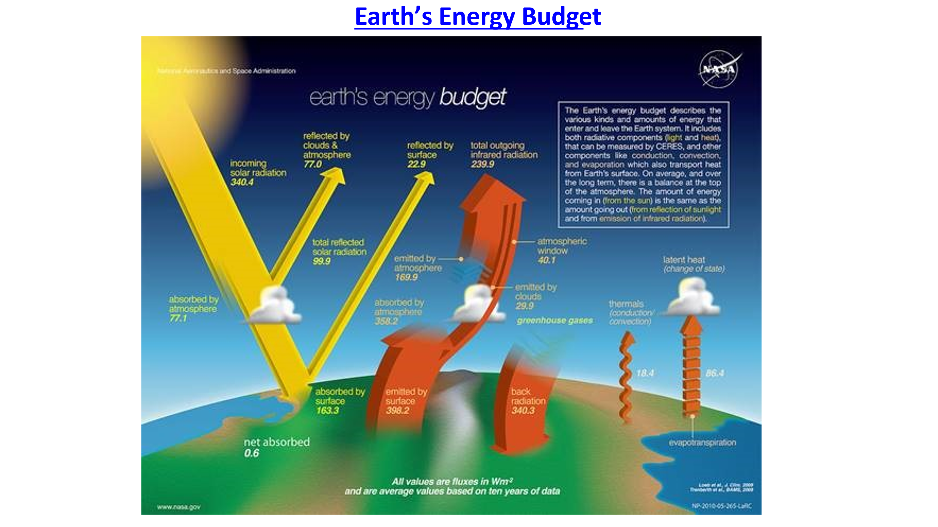

**Figure 1**: Understanding Extreme Heat Events: Radiant Energy

[Earth's Energy Budget | MyNASAData](https://mynasadata.larc.nasa.gov/basic-page/earths-energy-budget#:~:text=Earth%20strives%20to%20maintain%20a,emits%20energy%20back%20to%20space.)

**Conversion of Solar Energy to Heat Energy:** Solar energy is responsible for the heating of the earth’s atmosphere (air temperature) and makes any physical object exposed to it, hotter. The surface of a solid object like a street, sidewalk, building rooftop or south facing building façade can warm rapidly when exposed to sunlight. This happens when solar energy is absorbed by solid objects and converted to heat energy. However, the heat energy absorbed by objects can continue to build and can rise well above the air temperature by as much as 30 degrees or more. Additionally, the heated solid objects lose their heat energy slowly. This phenomenon is the cause of the urban heat island effect (UHIE), when daytime temperatures in built environments rise higher than in shaded parks and forests, and then maintain those higher temperatures overnight. During extreme heat events temperatures at night can be just as deadly as during the day.

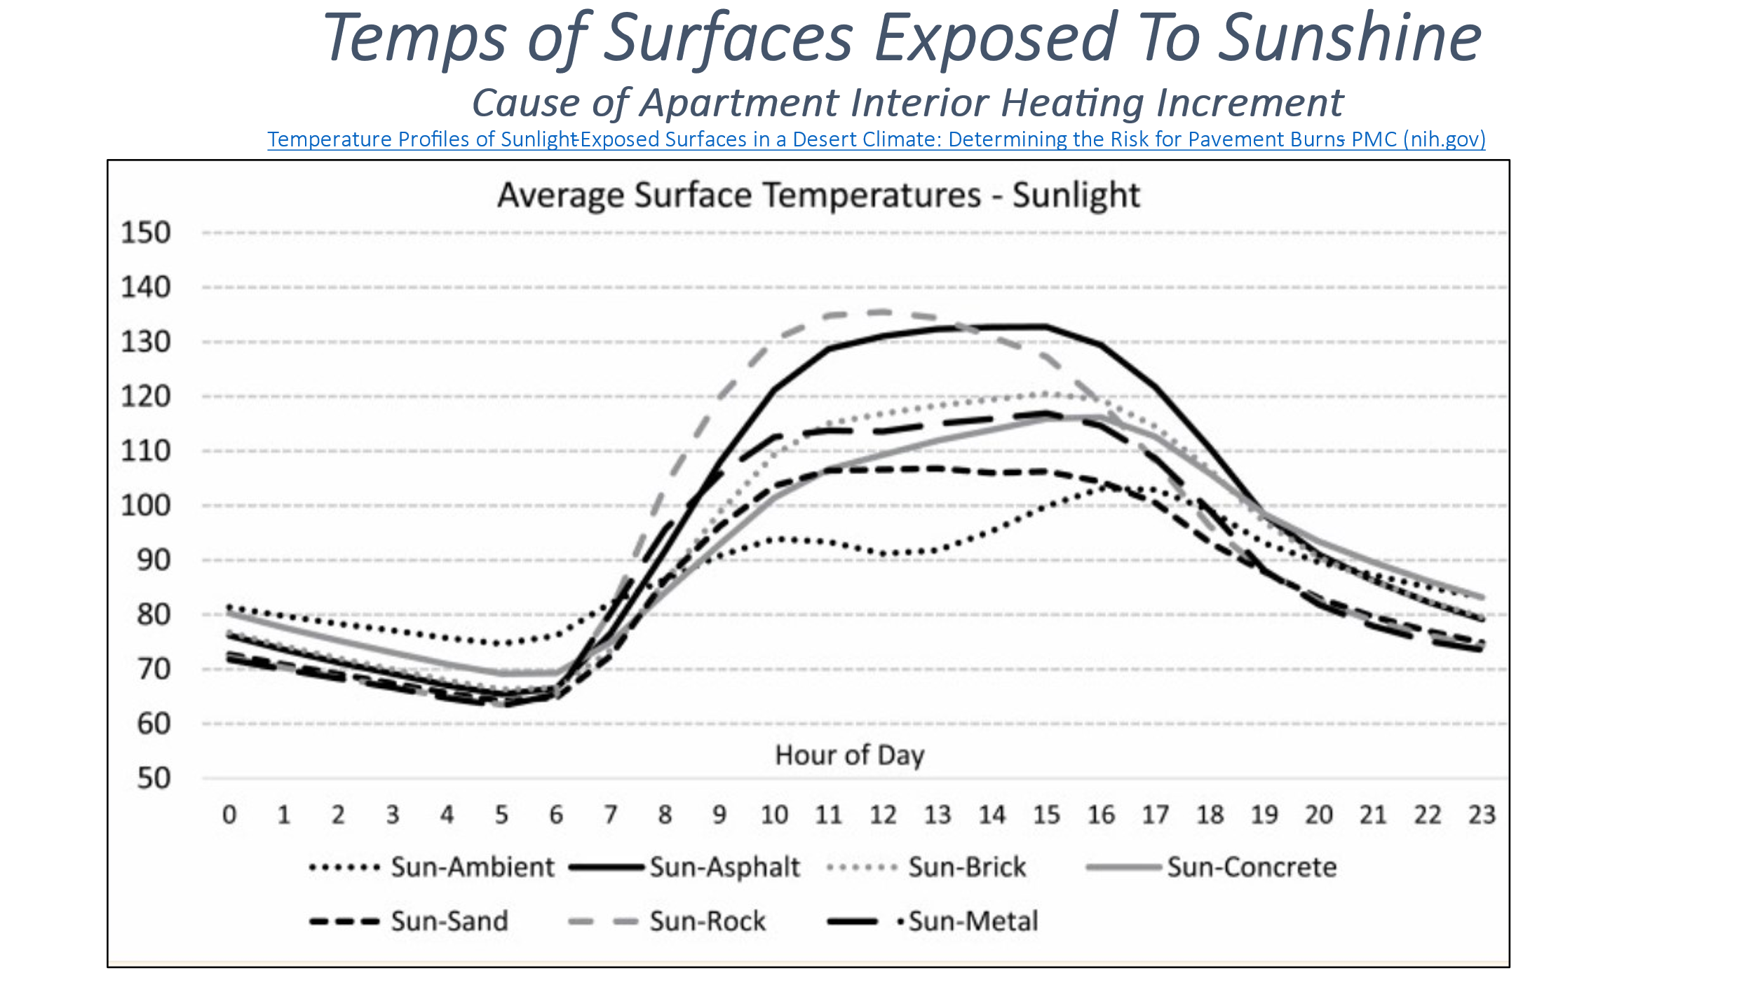

**Figure 2: Temps of Surfaces Exposed to Sunshine**

**Types of Extreme Heat Events:** Certain atmospheric phenomena are responsible for extreme heat events. Global warming caused by increases of heat trapping molecules in the atmosphere has been raising atmospheric and oceanic temperatures for decades and increases the likelihood of extreme heating events. El Nino, results when warmer water rises to the surface of the Pacific Ocean leading to higher global temperatures. Both of these phenomena can increase the frequency and intensity of “heat dome” formation, occurring when a high-pressure system traps warm air beneath it, compresses it, seals it off, and allows sunlight to heat it up to levels significantly higher than normal. In the northeast U.S. we are also familiar with the action of a” Bermuda High Pressure System” which stations itself above the Atlantic Ocean and with a clockwise circulation pushes warm, humid air north from the southern U.S. Such weather systems can raise temperatures above normal by twenty degrees or more.

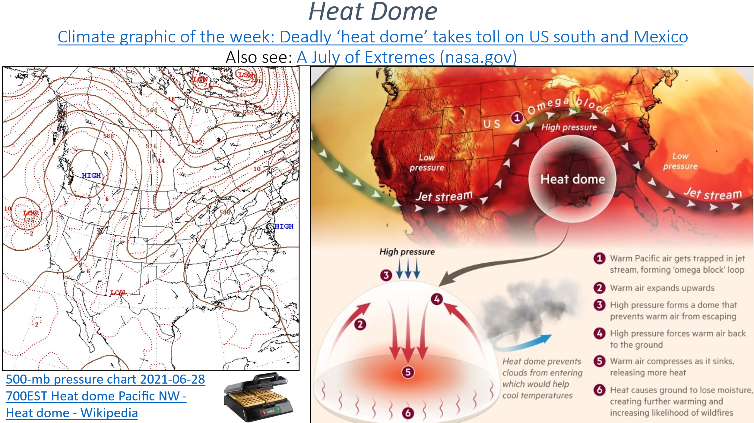

**Figure 3: Heat Dome**

**1.2 Temperature “Layer Cake”**

Knowing both outdoor and indoor temperatures is part of everyday living for most people. But during periods of summer heat, knowing the temperature is essential for self-protection. When the temperature exceeds a certain point, lives can be endangered. However, for most people, the temperature readings provided by weather reports are based on the readings captured by sensors in shady locations away from heat intensifying built surfaces. These temperatures form a neutral baseline that allows comparisons across decades of time, uninfluenced by the changing physical landscape. Referred to as the dry bulb temperature, or the ambient air temperature, these reading however, do not reflect the temperatures experienced by the vast number of people living in the built-up areas of cities. Such urban landscapes experience a number of heat related increments leading to a heat layering effect.

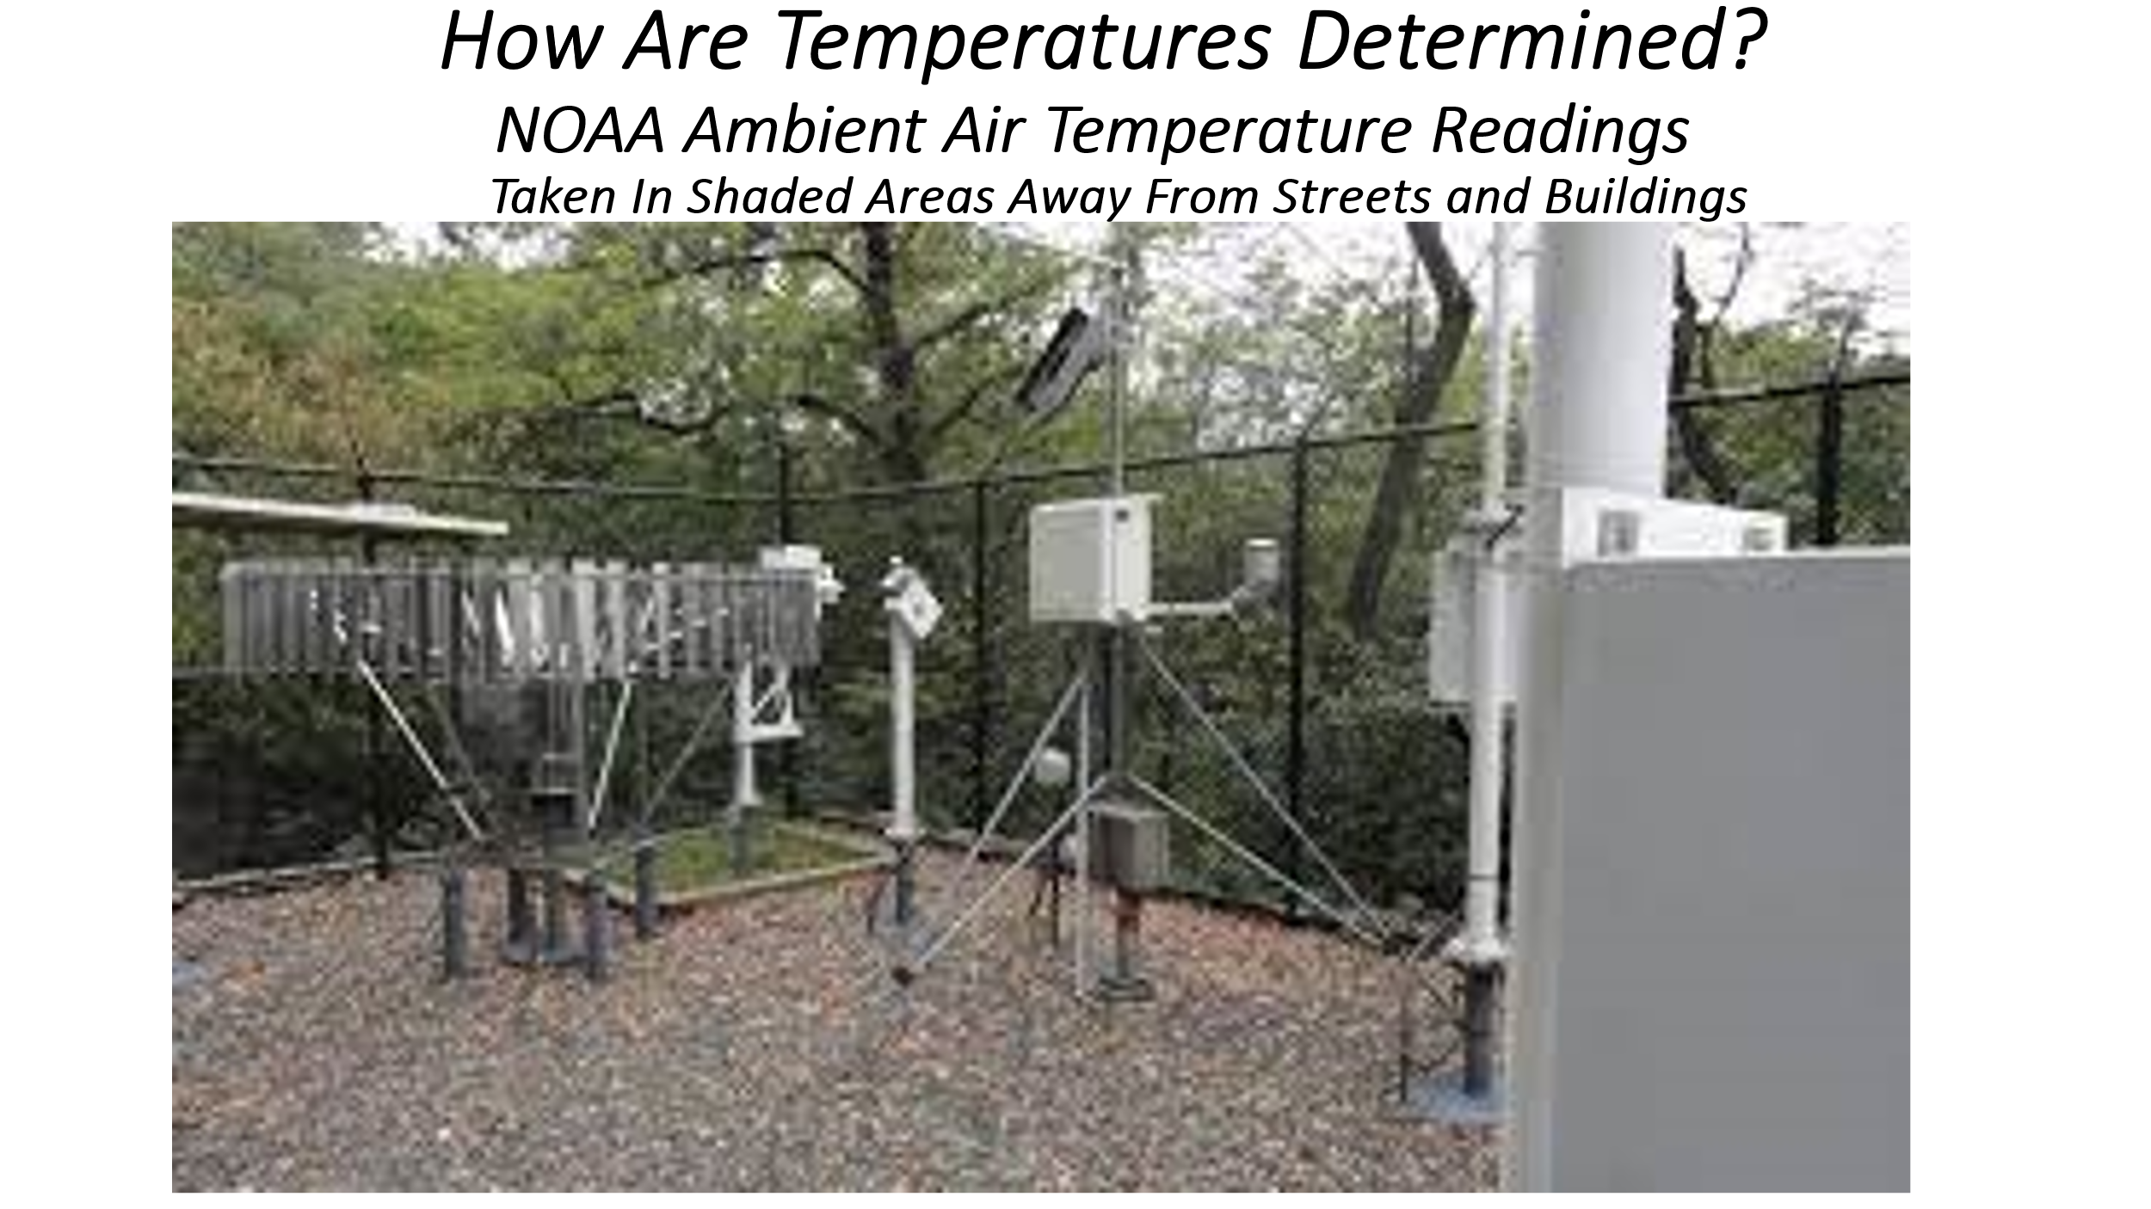**Figure 4: NOAA Weather Station in Central Park, NYC** [Central Park, NY Historical Data (weather.gov)](https://www.weather.gov/okx/CentralParkHistorical)

**Heat Index:** Weather reports, in addition to providing air temperature readings, may also note the heat Index reading which reflects the additional discomfort felt by people due to the humidity level. High humidity makes it more difficult for people to cool off because high moisture content in the air interferes with the evaporation of sweat which is the primary way humans have to maintain a normal body temperature. Thus, at a temperature reading of 100 degrees and a humidity level of 40 percent, the NOAA Heat Index chart shows that the temperature feels like 109 degrees. At 50 percent humidity, a 100 degree temperature reading feels like 118 degrees. [What is the heat index? (weather.gov)](https://www.weather.gov/ama/heatindex#:~:text=If%20you%20are%20exposed%20to,physical%20activity%20in%20the%20heat.)

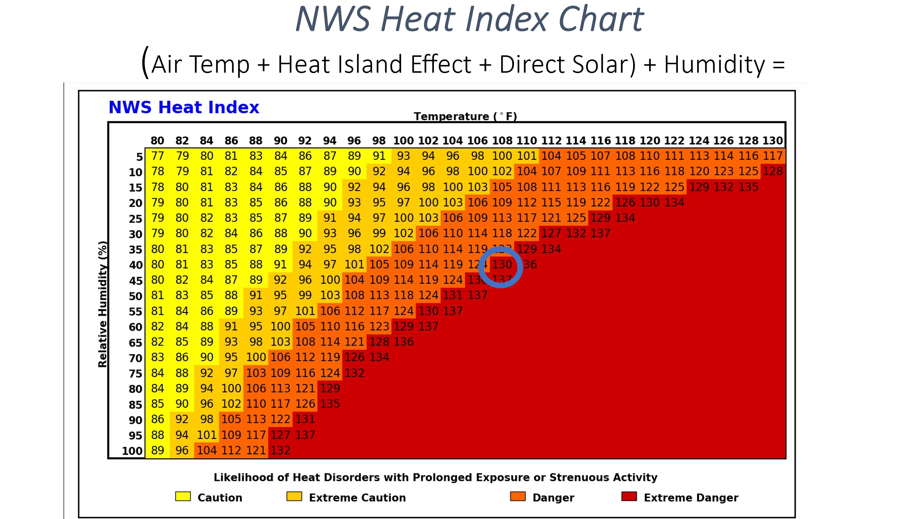

**Figure 5: National Weather Service Heat Index Chart**

**Urban Heat Island Effect (UHIE):** It has been long known that solar energy, absorbed by non-reflective (low albedo), solid surfaces in urban areas, can raise temperatures above the readings found in parkland or rural areas populated by trees. Various attempts to document the urban heat island effect find that the UHIE can add as much as ten degrees or more to the ambient air temperatures recorded at NWS weather stations. Moreover, because solid objects surrender their heat slowly, higher temperatures persist throughout the late evening, night, and early morning. When an urban heat island effect adds ten degrees to a 100-degree reading at a weather station, the temperature measured in built-up neighborhoods and inside sun exposed residential interiors can be as much as 110 degrees or more. When the humidity level is 40 percent, the felt temperature, or Heat Index, is 136 degrees! This temperature is judged to be extremely dangerous to human life, especially for vulnerable individuals, and can rapidly lead to death. When the humidity level is fifty percent, the heat index is an astonishing 152 degrees!! See Figure 7. Also see [Heat Index Calculation (noaa.gov)](https://www.wpc.ncep.noaa.gov/html/heatindex.shtml)

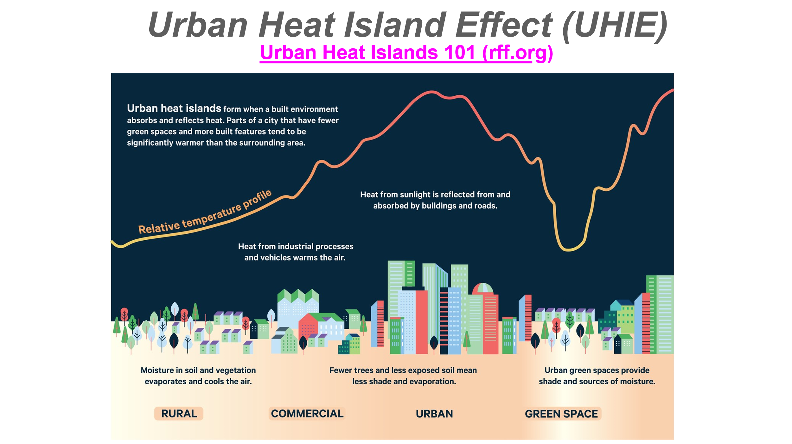

**Figure 6: Urban Heat Island Effect (UHIE)**

**The Sustaining of Heat Build Up In Interior Spaces at Night:** During late afternoons of sunny summer days and continuing through the night, the outdoor temperature begins to drop while humidity levels tend to rise. In Figure 7.1 we see a night time scenarios where outdoor temperatures drop ten degrees from their 100 degree high to 90 degrees, and humidity levels rise to 50 percent or 60 percent. Under these conditions the heat island effect is presumed to maintain a ten-degree higher temperature in building interiors that had been exposed to the sun during the day. When night time temperatures drop to 90 degrees in Central Park temperatures within sun exposed apartments can maintain temperatures of between 118 and 129 degrees. The persistence of high heat within residences even through the night is among the most dangerous characteristics of the urban heat island effect. It therefore should come as no surprise that most people who die during an extreme heat event, die in their residences. [Climate and Health Technical Report Series: Technical Documentation on Exposure-Response (cdc.gov)](https://www.cdc.gov/climateandhealth/docs/HeatResponsePlans_508.pdf) This is likely why urban residences seek relief from the heat away from the street and outside their apartments, either in parks or on fire escapes and balconies. Also see: [Predictors of summertime heat index levels in New York City apartments - PMC (nih.gov)](https://www.ncbi.nlm.nih.gov/pmc/articles/PMC5812346/)



**Figure 7.0 and 7.1: Daytime High and Night Time Low Temperatures**

**2.2 The Role of NOAA, NWS, and the NYC Regional Forecast Office**

The National Weather Service (NWS) can effectively predict the onset of extreme heat events days and even weeks in advance, and through its network of 122 local forecast center, efficiently relays critical information to emergency response leaders and executives at the Federal, State, Local and Private level through web postings, conference calls, and person to person consultation.

Most weather reports issued by the NWS predominantly use air temperature readings (dry bulb) taken at NWS sites such as Central Park. These sensor readings are required to be taken in shady green areas at a distance from buildings and streets and other dense, dark, impermeable heat aborbing and radiating surfaces. The NWS also routinely indicates the humidity reading and the heat index.

NWS weather forecasts are based on a 2.5 square kilometer grid (equal to about 1.0 square mile). However, the NWS does not forecast temperatures at the street, building, or apartment level making it difficult for individuals to understand their level of heat risk where they live.

NWS local forecast offices have the ability to work with jurisdictions within their forecast areas to utilize estimates of the urban heat island effect. CDC may have the ability to use measured or estimated temperature increases within residences that are directly exposed to solar energy. When the heat index or the urban heat island effect are not utilized, temperature readings and predictions can be 10 degrees to 20 degrees or more below what people experience on the street, in their homes, and in their work places. (Just as a hurricane’s wind gust velocities are reported along with its sustained wind speeds; and storm surge estimates come with tide and wave height supplements; so should baseline air temperatures during extreme heat events, come with the additional heat readings associated with the urban heat island effect and the extra heating that occurs in solar exposed residential and workplace interiors.)

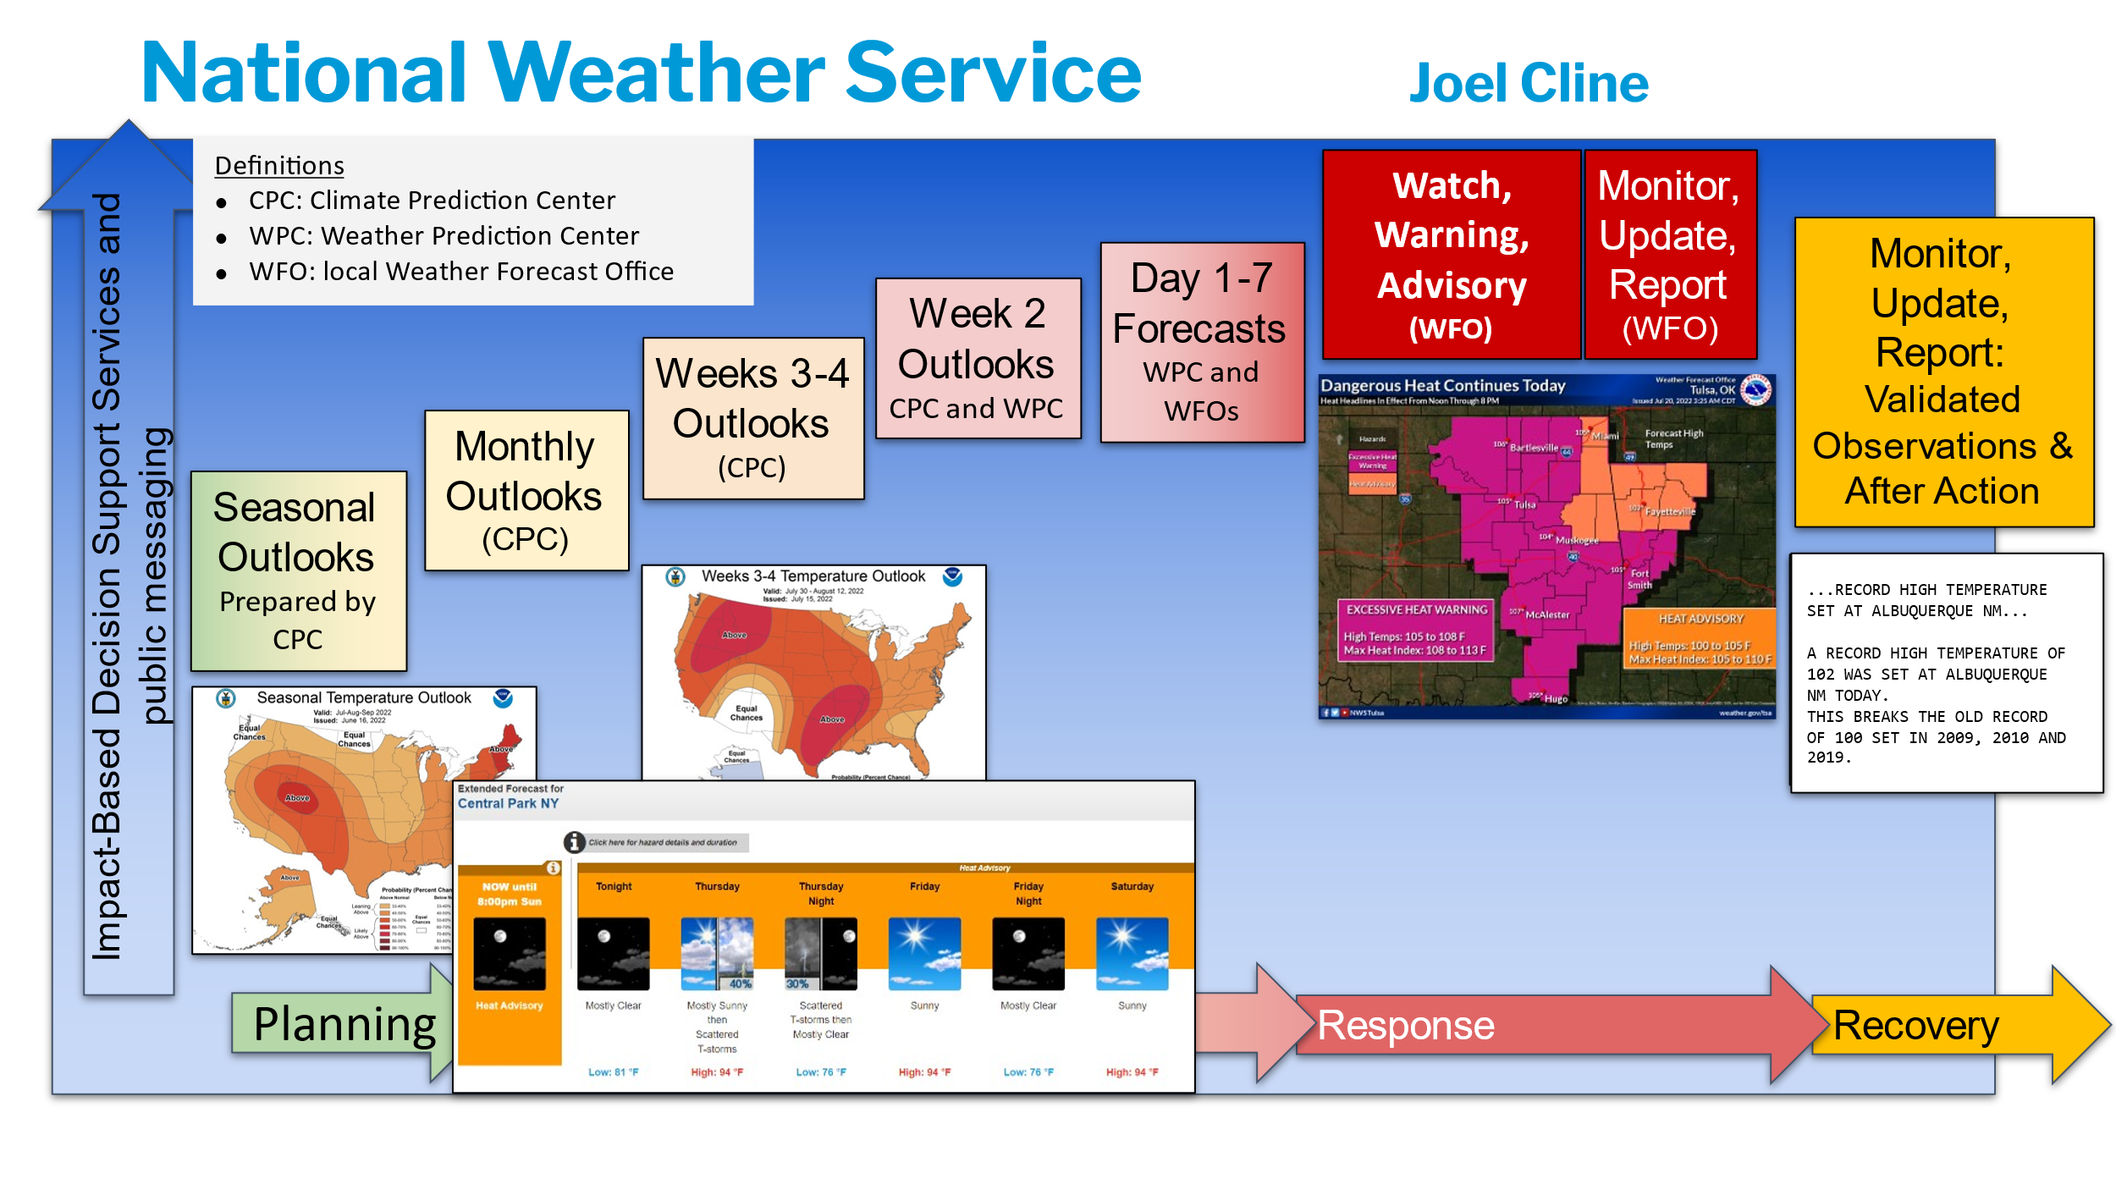

**Figure 8: National Weather Forecasting Schedule**

**2.3 The North Manhattan Study Area** [List of heat waves - Wikipedia](https://en.wikipedia.org/wiki/List_of_heat_waves)

To better understand urban heat, the GISMO team chose a Study Area in northern Manhattan bounded by the Hudson River, 110th Street, 5th Avenue, East 96th Street, the East River, and the Harlem River. It includes Manhattan Community Districts 9 (West Harlem), 10 (Central Harlem), 11 (East Harlem), and 12 (Inwood and Washington Heights). This study area has a population of about 609,000 residents and we are estimating that ten percent, or 60,900 do not have, or do not use air conditioners (AC). With the total NYC population now estimated at 8.25 million, our study area represents 7.3 percent of City residents. One in every 13.5 New Yorkers lives in our study area. The neighborhoods comprising our study area contains a mix of income levels and has a varied ethnic and racial profile. One reason this area was selected was due to a NOAA field study of temperatures, captured by community volunteers, that show a significant heat island effect. (See: [OSF | Heat Watch Bronx-Manhattan_Report_111021.pdf](https://osf.io/pvd9f))

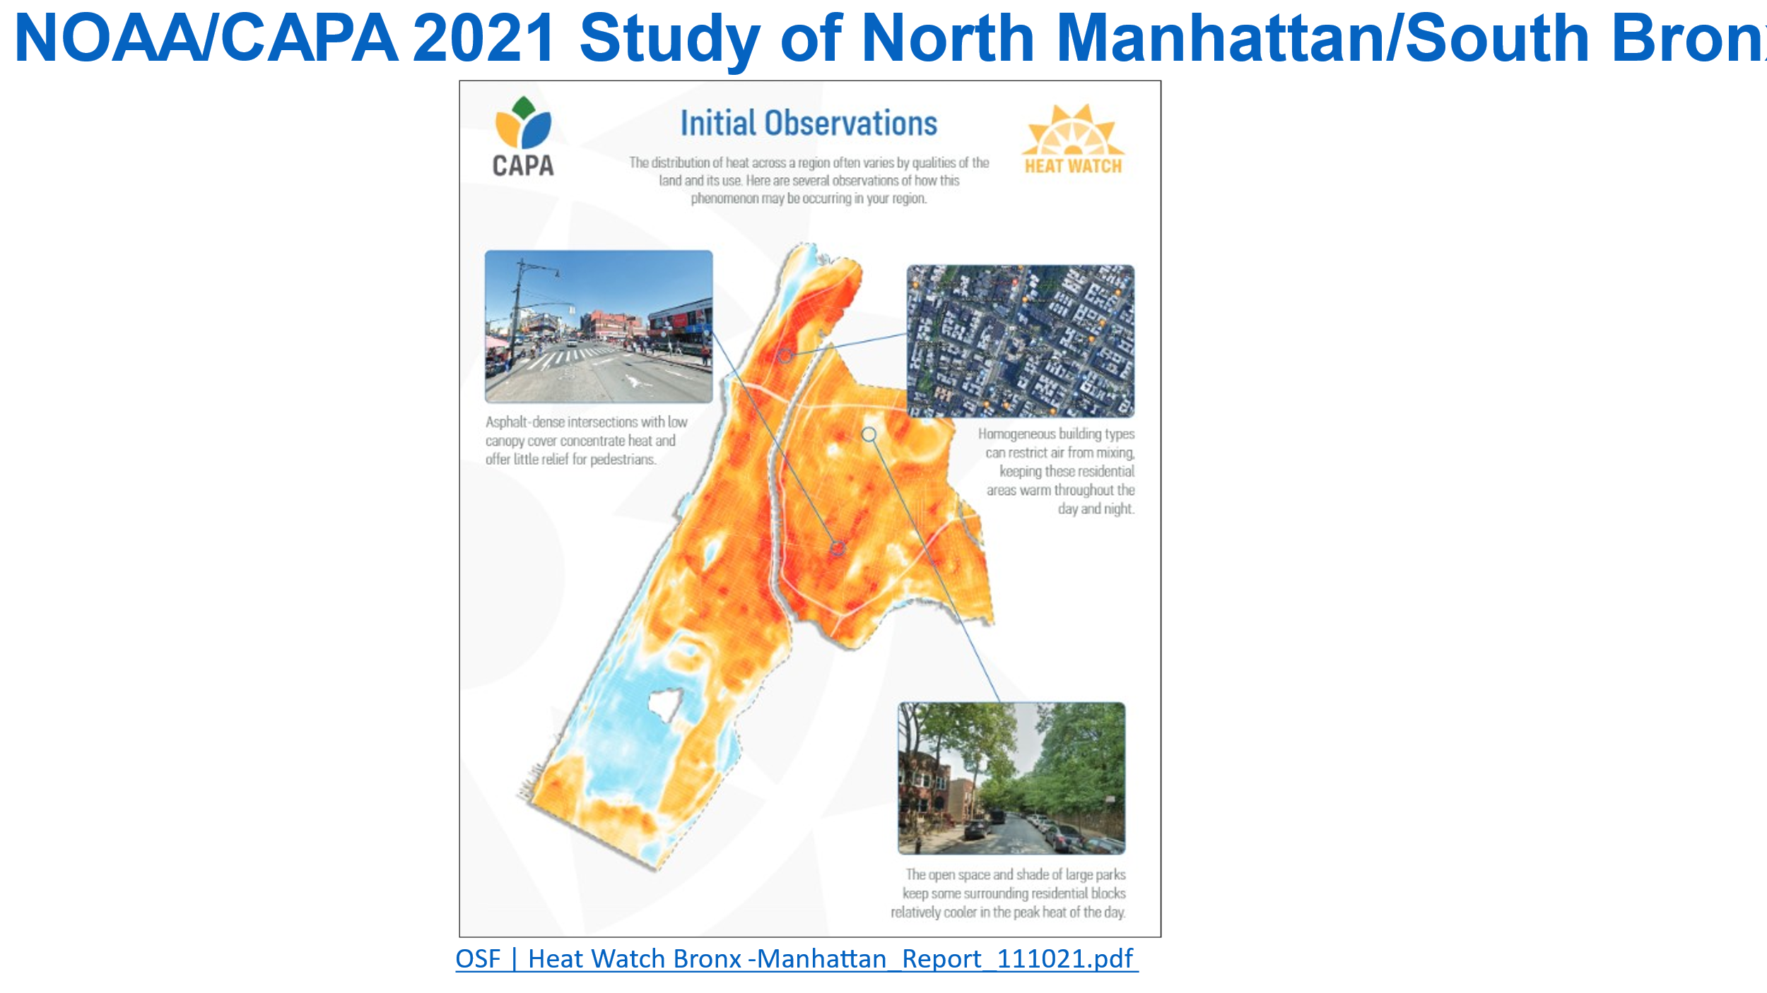

**Figure 9: North Manhattan NOAA Study Area:** [OSF | Heat Watch Bronx-Manhattan_Report_111021.pdfOSF | Heat Watch Bronx-Manhattan_Report_111021.pdf](https://osf.io/pvd9f)

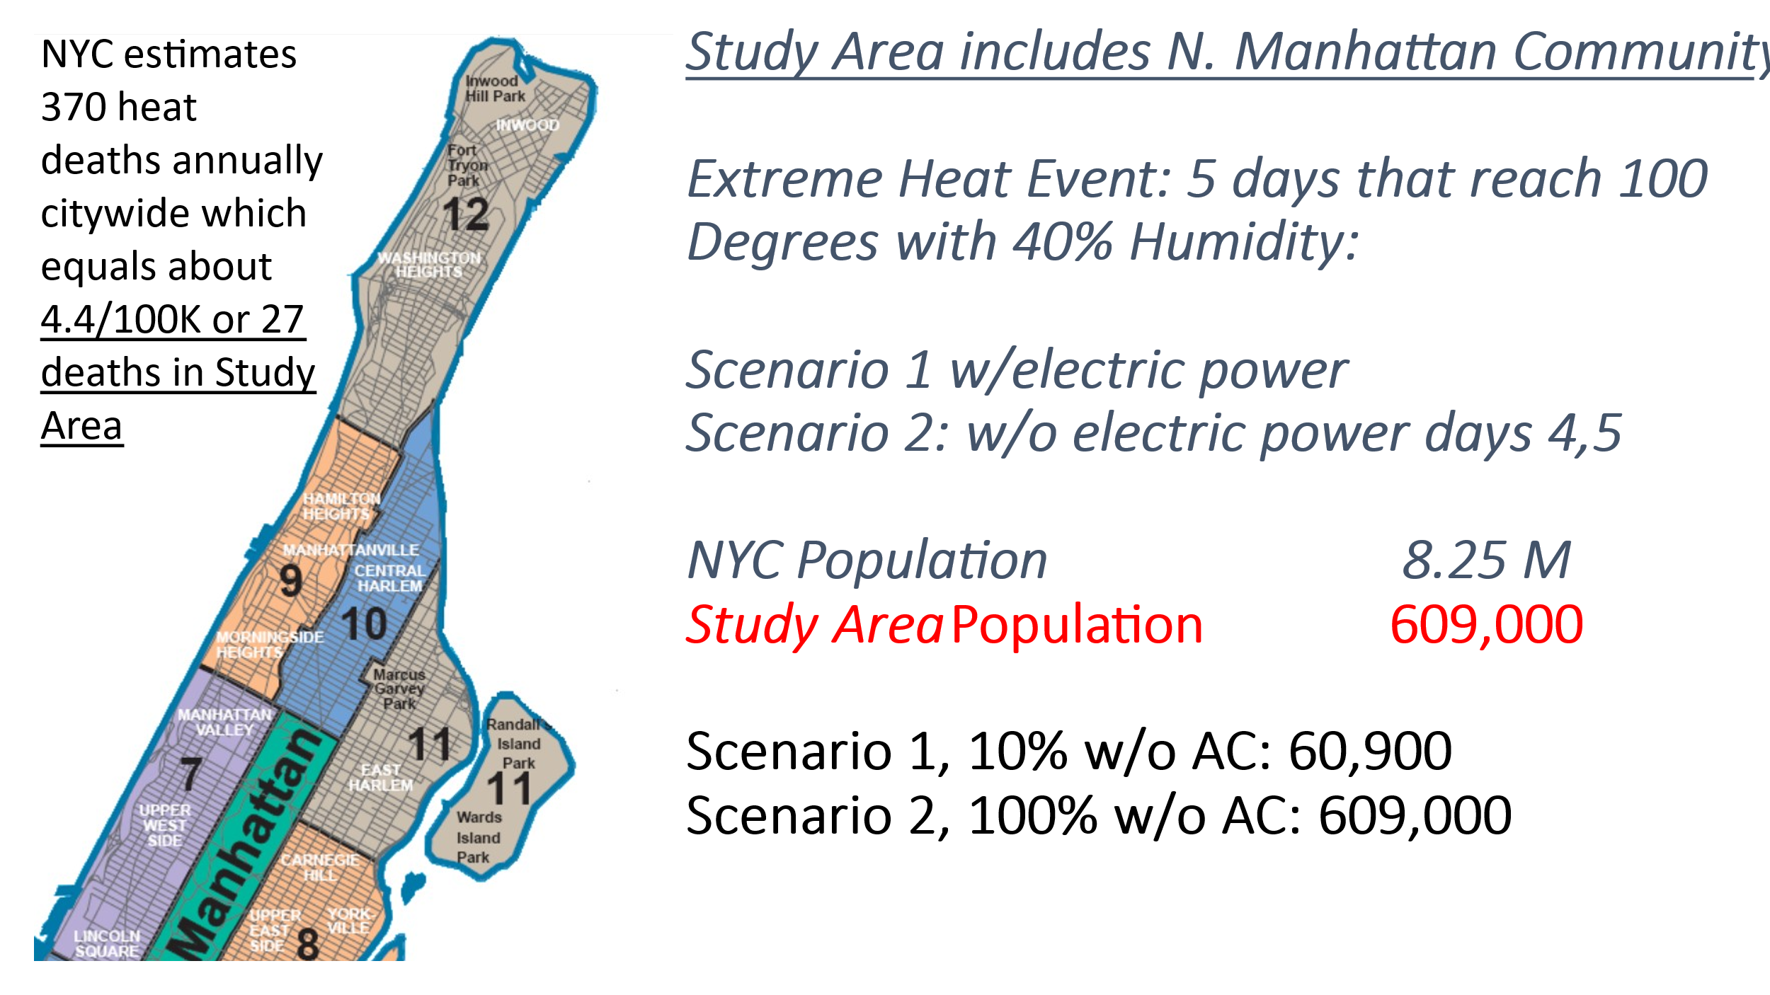

**Figure 10: North Manhattan OGC Extreme Heat Study Area**

**2.4 Study Scenarios**

**Study Scenarios**: Powerful heat waves have been regular occurrences in NYC as illustrated by Figure 11. Moreover, NYC has experienced electric power blackouts that have extended from twelve hours to more than a week. The project team felt that to more fully understand the consequences of an extreme heat event in NYC, especially given rising global temperatures, we needed to select scenarios that reflected near worst cases that were within the bounds of plausibility. The scenarios we choose were: Scenario 1 - a heat wave lasting five days during which temperatures reached 100 degrees each day with humidity levels of 40 percent; and Scenario 2: the same heat wave compounded by an electric power blackout in our study area lasting 48 hours or 2 days. Figure 12 lists electric power blackouts affecting NYC since 1959. [List of heat waves - Wikipedia](https://en.wikipedia.org/wiki/List_of_heat_waves) ; [Blackout in New York - Wikipedia](https://en.wikipedia.org/wiki/Blackout_in_New_York)



**Figure 11:** Longest Heat Waves NYC: 3 days of 90 degree temps; 1869 to Present  
[HeatWaves.pdf (weather.gov)](https://www.weather.gov/media/okx/Climate/CentralPark/HeatWaves.pdf)

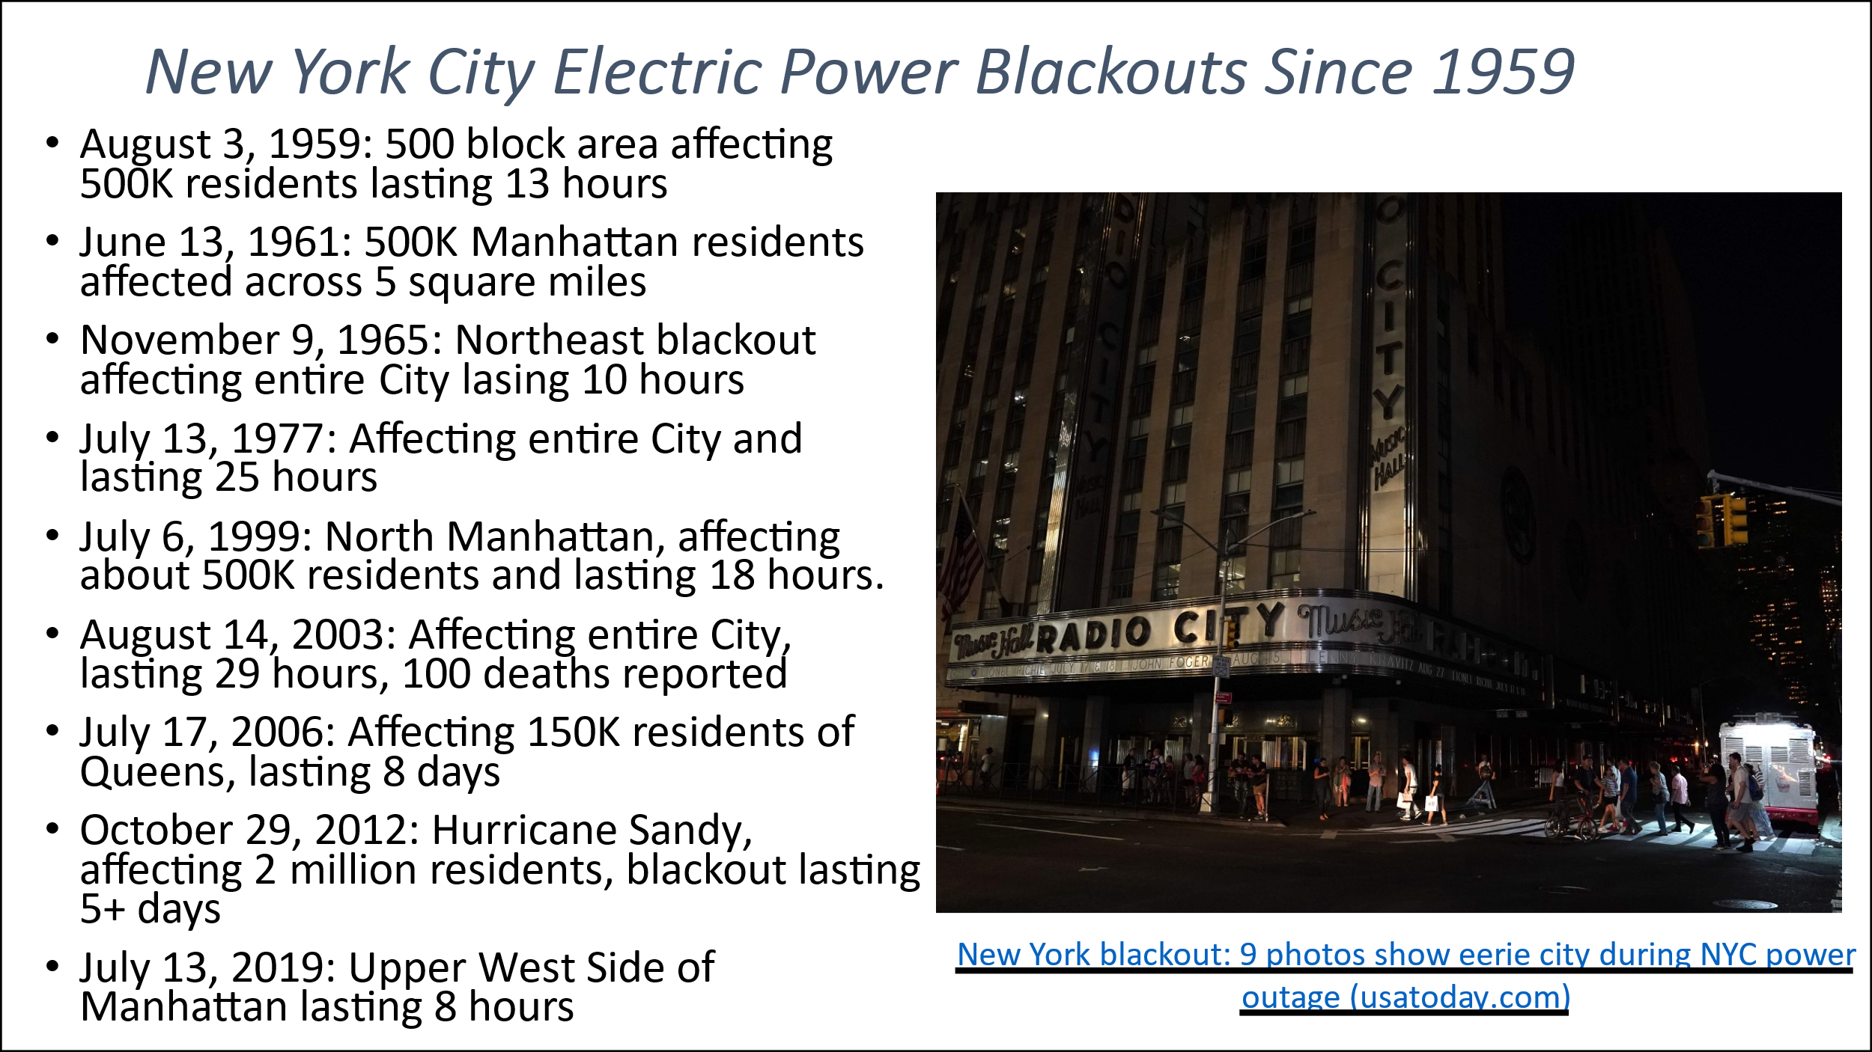

**Figure 12:** NYC Electric Power Blackouts (See: [A brief history of blackouts in New York City | amNewYork (amny.com)](https://www.amny.com/news/blackouts-nyc-1-33881190/) **2.5 Modeling Heat Distribution:** Dean Hintz, Safe Software

The effects of extreme heat events do not spread themselves evenly across large, varied urban areas. City parks with green areas and shade trees are significantly cooler than dense urban neighborhoods with asphalt roadways, concrete sidewalks and playgrounds, black tar roofs, steady streams of traffic and other human activity, and the exhaust of AC units blowing hot air out of sun exposed apartments. In order to understand how extreme heat affects the urban landscape and its inhabitants, it is essential that we learn to map with precision temperatures in all those places where people live and work. We need to know the temperatures experienced by residents of older, poorly insulated buildings, with single pane windows that do not provide effective insulation nor reflect solar energy. We need to know the air temperatures experienced by pedestrians whose shoes, and sometimes their skin, makes contact with streets that may be 150 degrees or more. With this information we can pinpoint the location of individuals who are at greatest risk and take smarter measures to protect them. We can calculate the scale of heat illnesses to better prepare medical workers and health facilities. We can also use this information to measure the improvements in temperature that are possible by planting trees, creating green spaces, painting roofs white, and providing window coatings that block the heat of the sun. Fortunately, thanks to satellites, improved sensors, and comprehensive GIS data about buildings, streets, and demographics, we have the ability to access and successfully utilize the information we need.

**Sensing and Detecting Temperatures on the Urban Surface:**

NOAA/CAPA Community Heat Surveys, and Climate Central Urban Heat Island Effect estimates within our northern Manhattan study area demonstrate that the heat island effect can add from between 1 degree to 12 degrees of heat to base temperature readings from the NWS weather station in Central Park.

**Climate Central** is a not-for-profit research organization whose purpose is to “communicate climate change science, effects, and solutions to the public and decision-makers” ([Urban Heat Hot Spots | Climate Central](https://www.climatecentral.org/climate-matters/urban-heat-islands-2023)). To date Climate Central has modeled the urban heat island effect for 44 U.S. cities including New York City. Their UHIE estimates are based on calculations that depend upon a number of weighted factors noted in Figure 13, including land cover, greenery, population density, street width, canyon orientation, and building heights ([Development of a holistic urban heat island evaluation methodology | Scientific Reports (nature.com)](https://www.nature.com/articles/s41598-020-75018-4). Urban Heat Island Effect temperature increases are assigned to census tracts so that they can be better aligned with demographic and health information. (See Figure 14) Of the cities studied so far, NYC has the largest heat island effect temperature increase due to its building density and high percentage of paved surfaces. The UHIE in our northern Manhattan study area ranges from +6 degrees along river waterfronts, to +12 degrees within dense urban corridors.

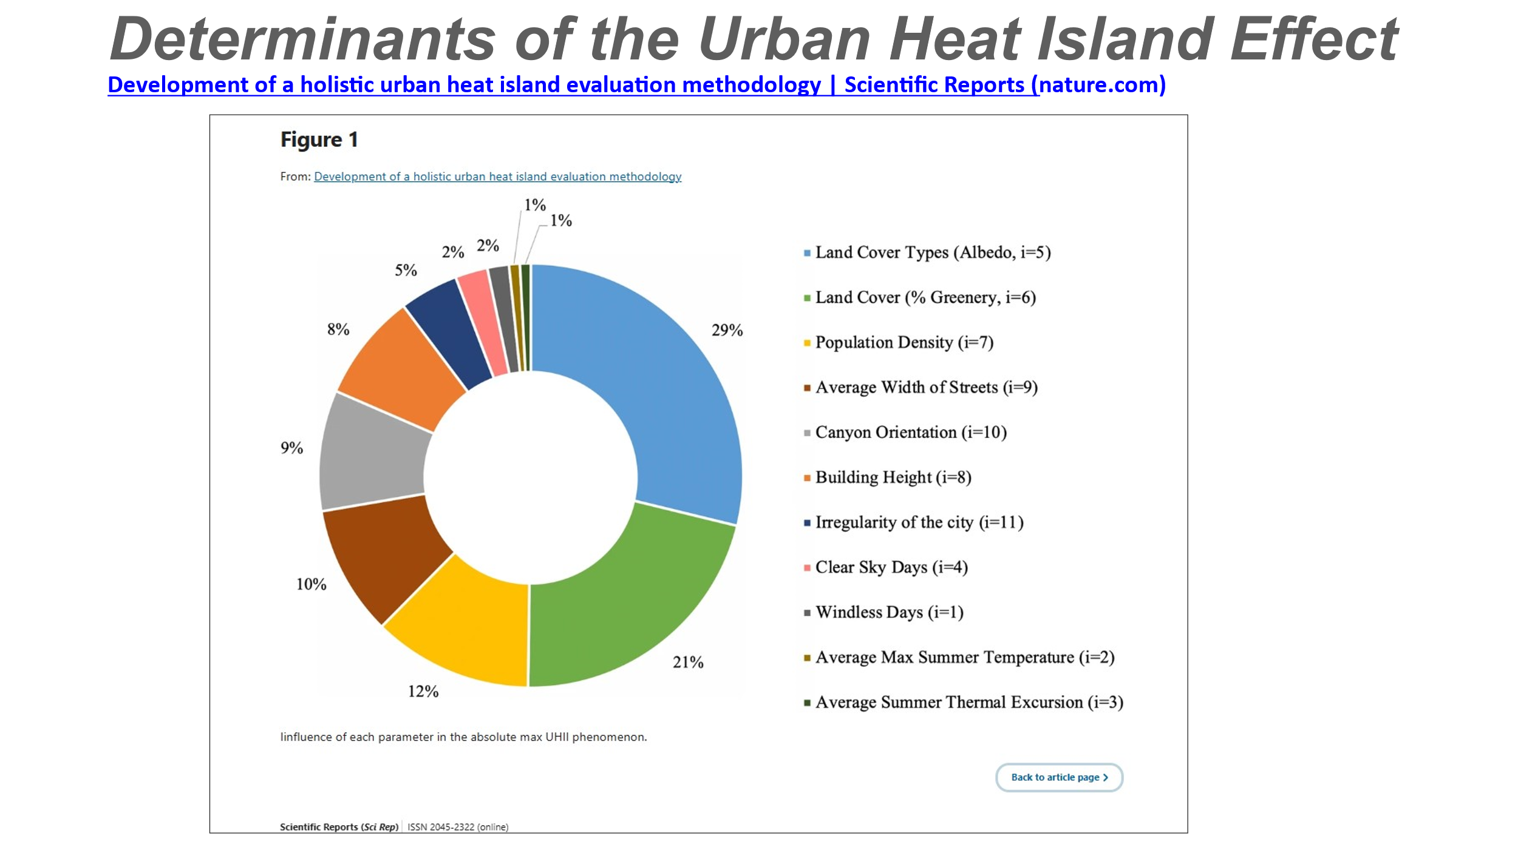

**Figure 13:** UHIE Determinants

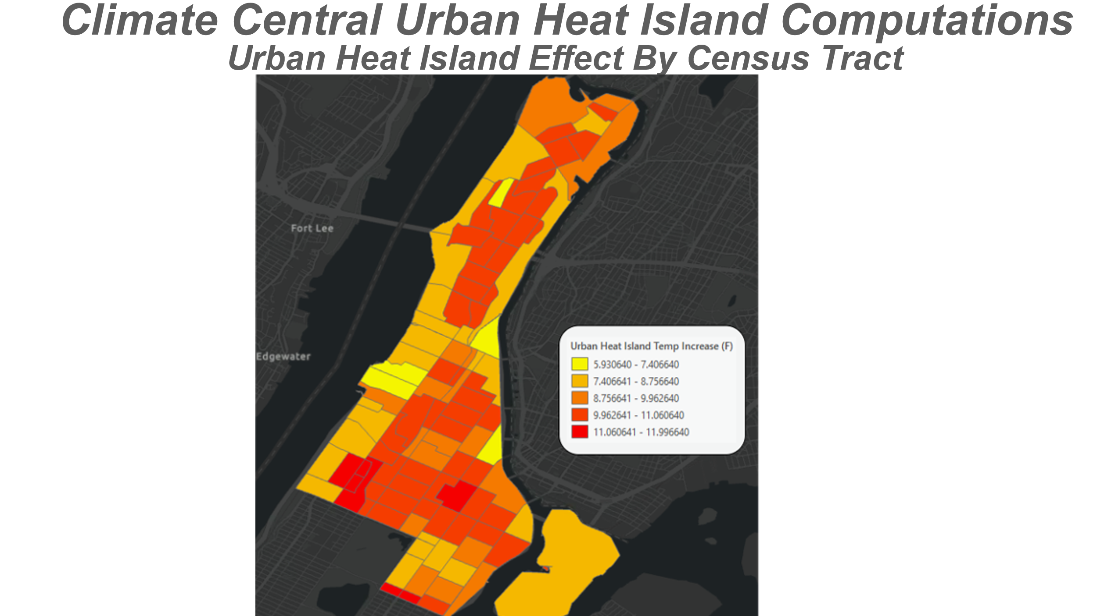

**Figure 14:** Climate Central’s UHIE produced by HSR.*health.* Aligns to social, demographic, and heat data at the census tract level

Having UHIE temperature readings as calculated by Climate Central’s by census tract opens many analytic options for assessing demographic and health characteristics, and allowing us to estimate the scale of illness, hospitalization, and death that might be caused by an extreme heat event. In Figure 15 below, through the use of a 3D model of the study area in CityGML, Navteca was able to model the intensity of solar radiation (insolence) across our study area to give us an idea of the heat island effect on individual streets, building roofs and facades, and to provide a clue as to which apartments will receive the greatest heat increment because of extended exposure to direct solar radiation. The heat mapping performed by the NOAA/CAPA team with the support of community volunteers largely confirms the Climate Central findings at street level. [OSF | Heat Watch Bronx-Manhattan_Report_111021.pdf](https://osf.io/pvd9f))

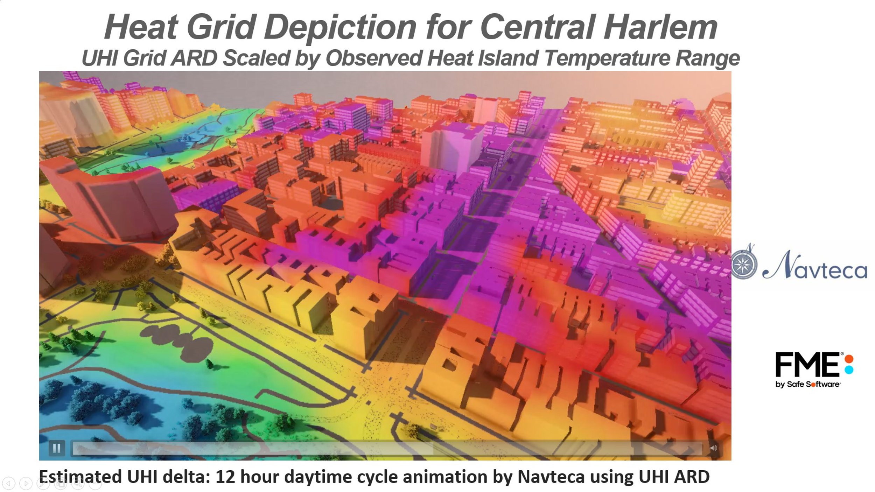

**Figure 15**: 3D Animated Heat Grid

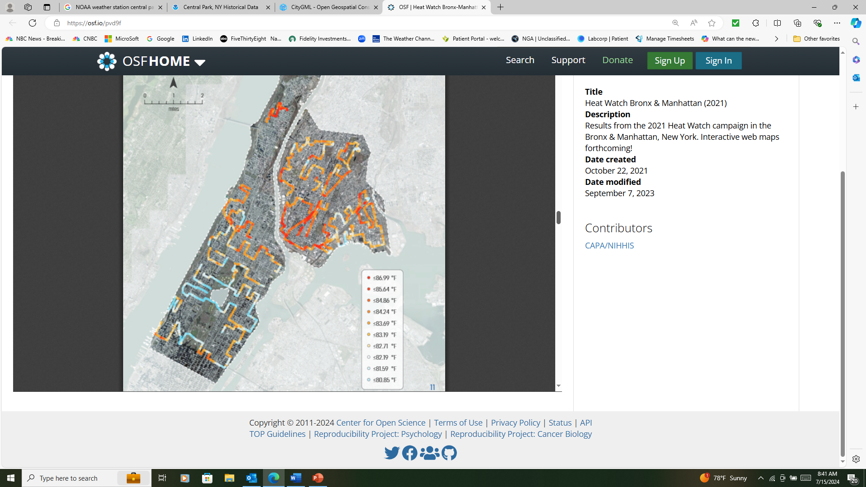

**Figure 16:** NOAA/CAPA 2021 Heat Study of North Manhattan/South Bronx

[OSF | Heat Watch Bronx-Manhattan_Report_111021.pdf](https://osf.io/pvd9f)

Dean Hintz of Safe Software has taken the initial steps of turning Climate Central UHIE data into more precise temperature readings, and then of estimating the numbers of individuals within each building who may be sickened by the heat. (See Figure 17) This can lead us to identifying all buildings within an urban area most likely to experience heat casualties, and which streets are the most in need of a heat mitigation strategies like tree plantings and increasing pavement reflectivity. Using these analytic and modeling techniques can also enable City officials to track progress in reducing the UHIE over time providing useful feedback on the effectiveness of measures taken. It is fortunate that NYC’s land use, building, and parcel data is accurately mapped, and full of useful attributes.

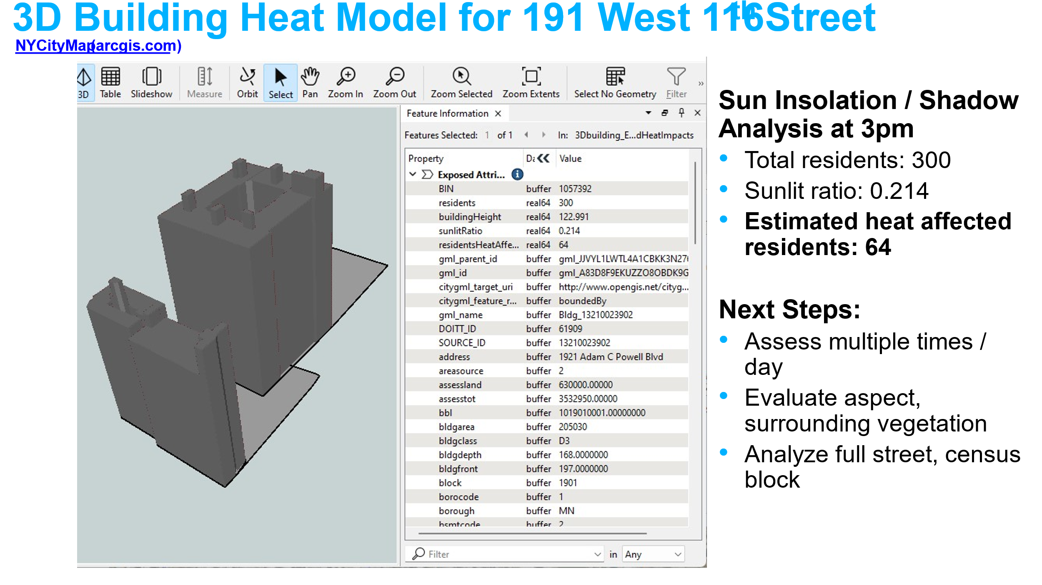

**Figure 17:** 3D Building Heat Model

**2.6 Health Impacts of Extreme Heat:** Ajay K Gupta, Paul A Churchyard, *HSR.health*

The most important purpose of this study is to understand the impacts of an extreme heat event on those people who are most vulnerable to its effects, whether based on their neighborhood, their incomes, or their health. Only by knowing how to identify and locate the most vulnerable, and accurately knowing the temperatures they are exposed to, can we be in a position to act in ways that safeguard their wellbeing. We have heard again and again that no one needs to die during an extreme heat event if proper personal actions, and community measures are taken. In this section we will look at how the communities that make up the northern Manhattan study area can be assessed to determine the scale of casualties that could result from the two extreme heat scenarios selected for study. A more complete health assessment can be found in the HSR.*health* supplementary report.

**Health Science and Background:** This section seeks to answer the following questions:What are the health effects of extreme heat? What are the diseases and conditions that extreme heat exacerbates? What can we learn from the patterns of death as a result of extreme heat events in Chicago (1995), Paris/Europe (2003), Vancouver (2023) and other examples.How are heat deaths quantified (coroners reports vs excess deaths)? What are the temperature inflection points along which deaths and hospitalizations gradually, then greatly accelerate?

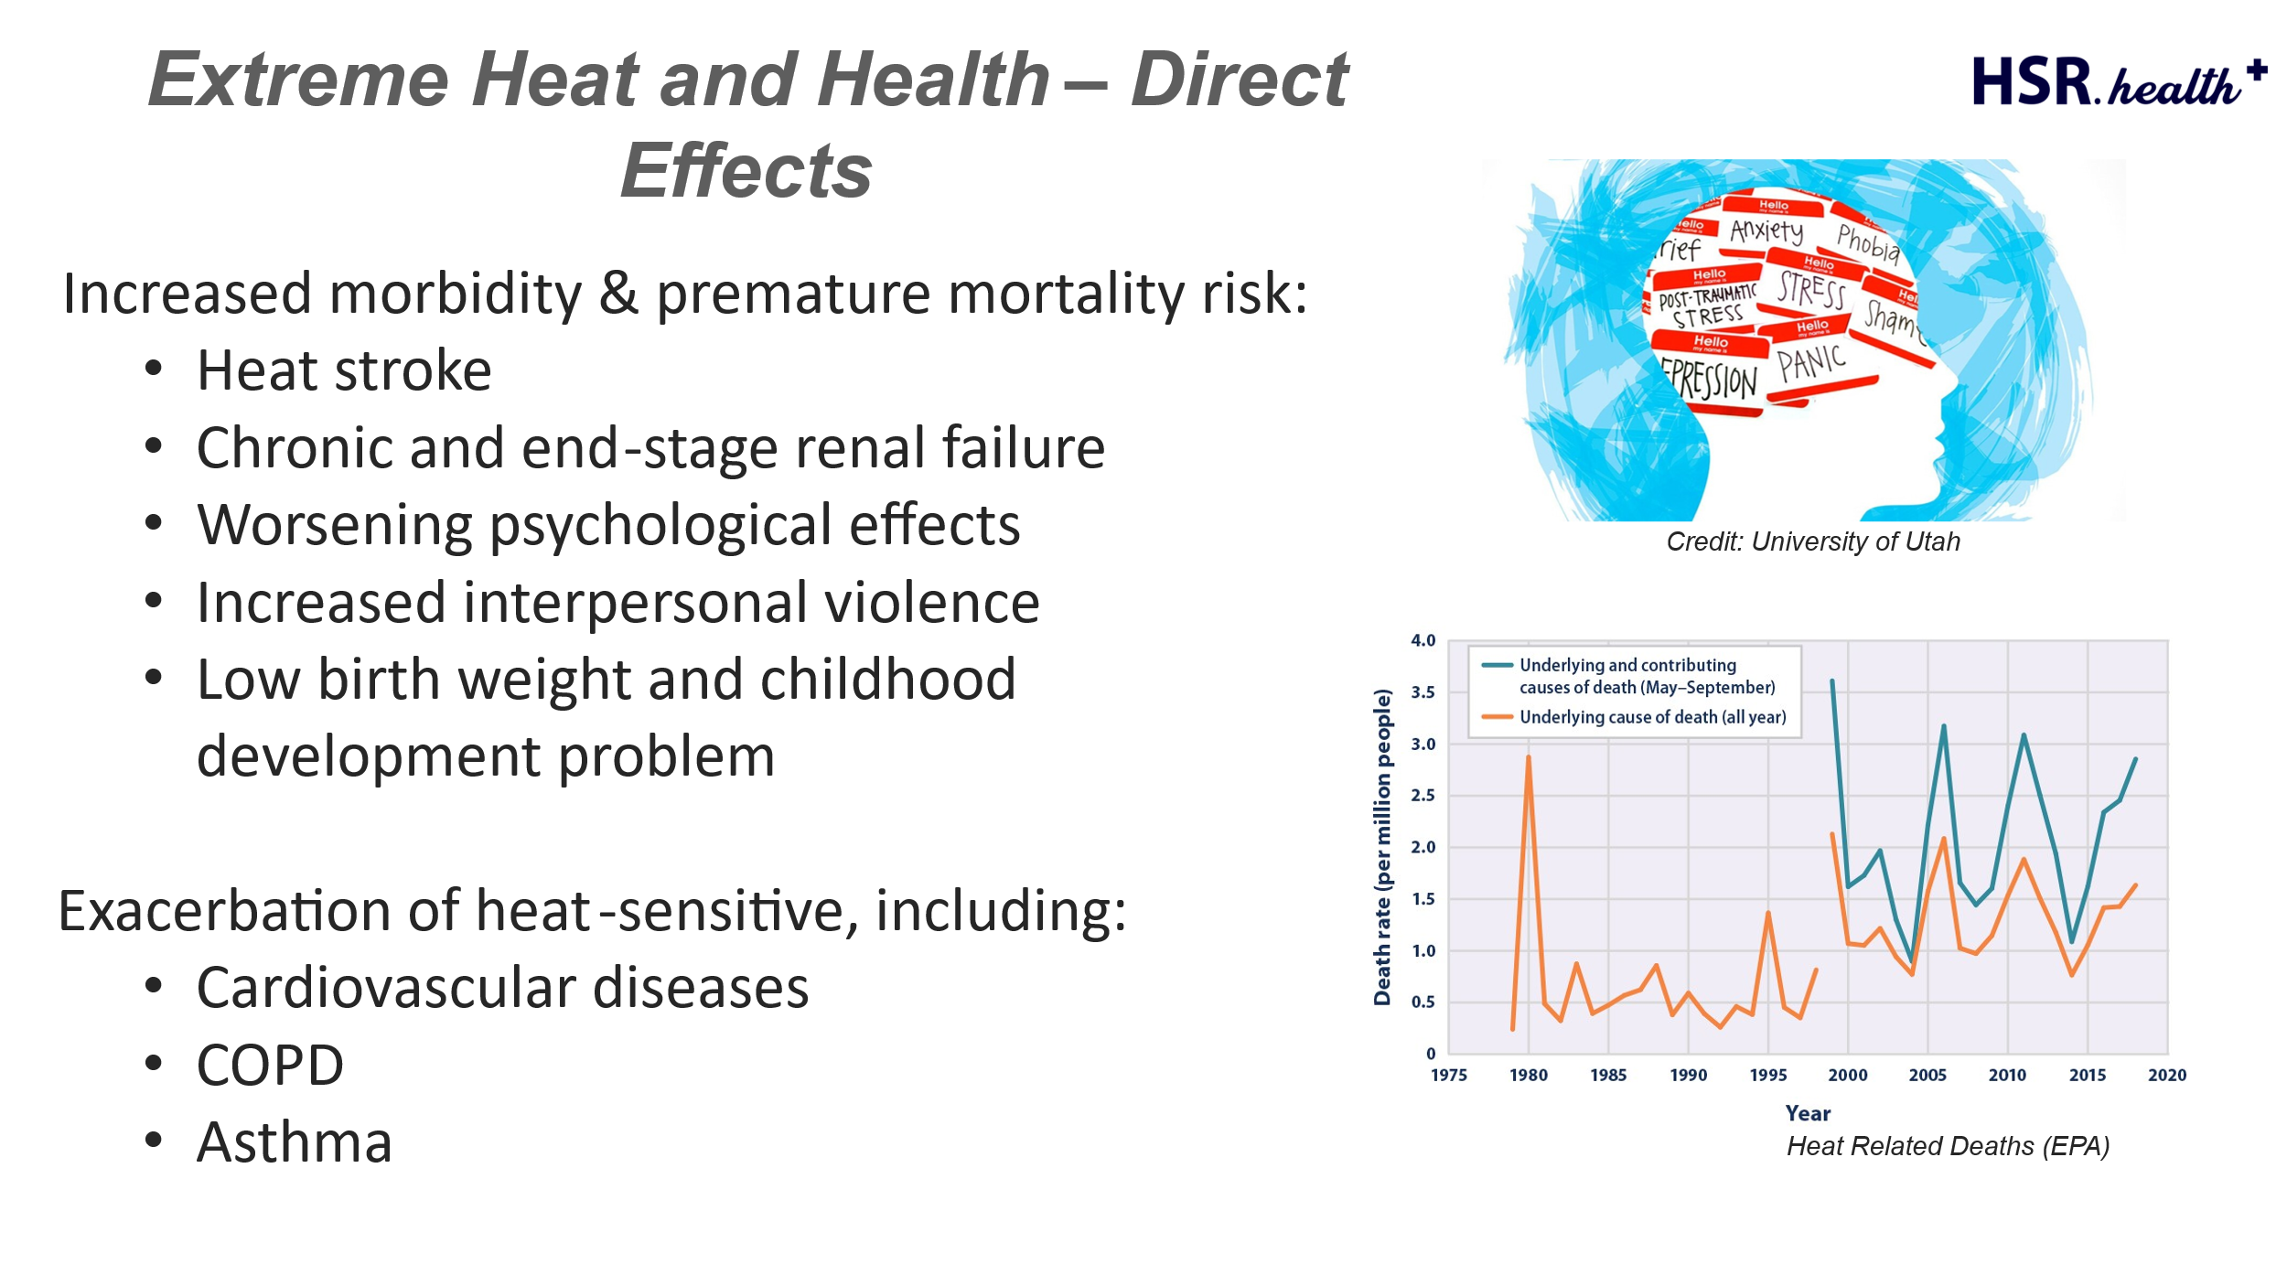

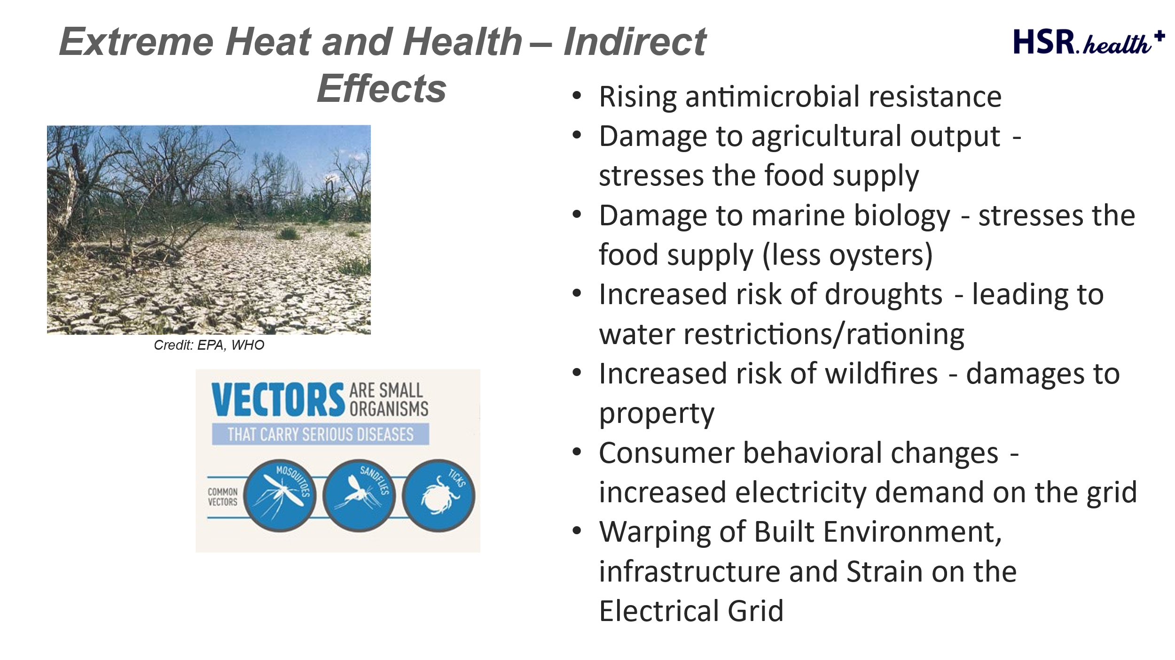**Past Incidents of Extreme Heat:** The Extreme Heat Study Team identified three examples of extreme heat to use as guides to the potential consequences of such an event in NYC. These examples included the Chicago heat wave of 1995, the Paris heat wave of 2003, and the Vancouver heat wave of 2021. Also see: [The Heat Will Kill You First - Wikipedia](https://en.wikipedia.org/wiki/The_Heat_Will_Kill_You_First), by Jeff Goodell.

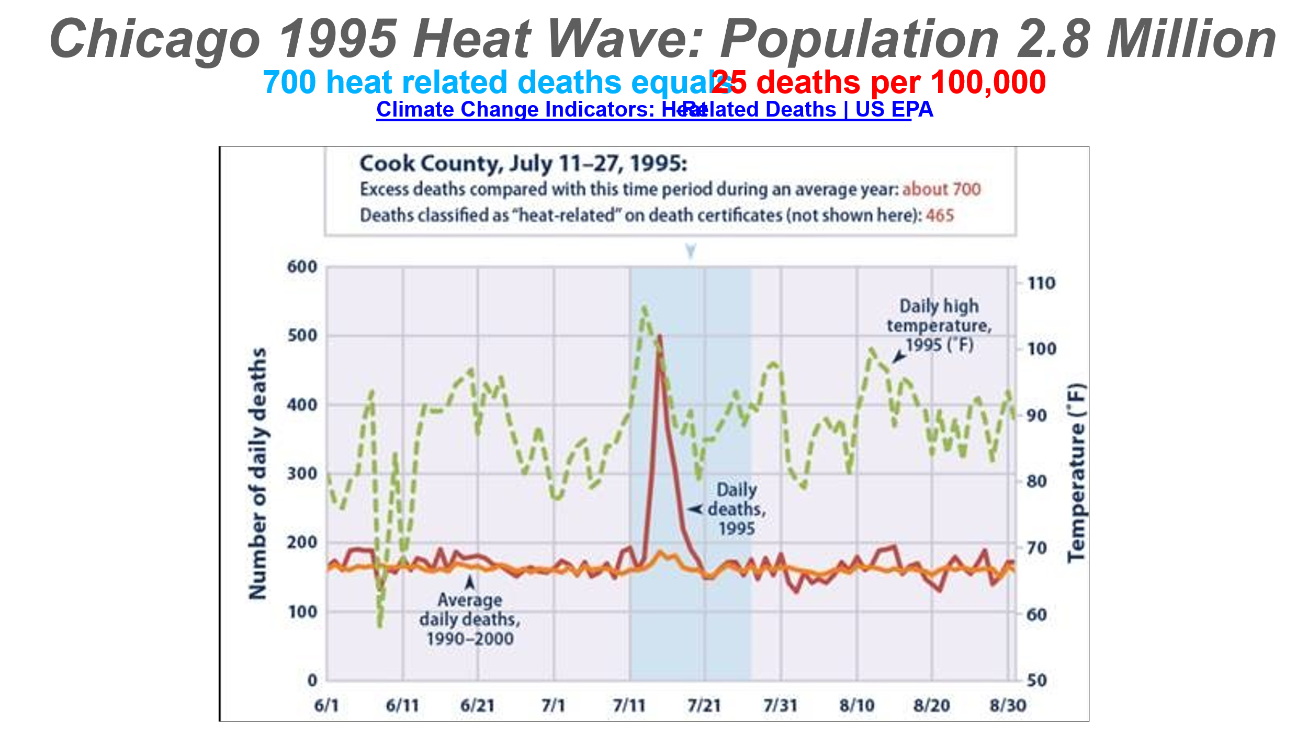

**Figure 18:** Chicago Heat Death Spike

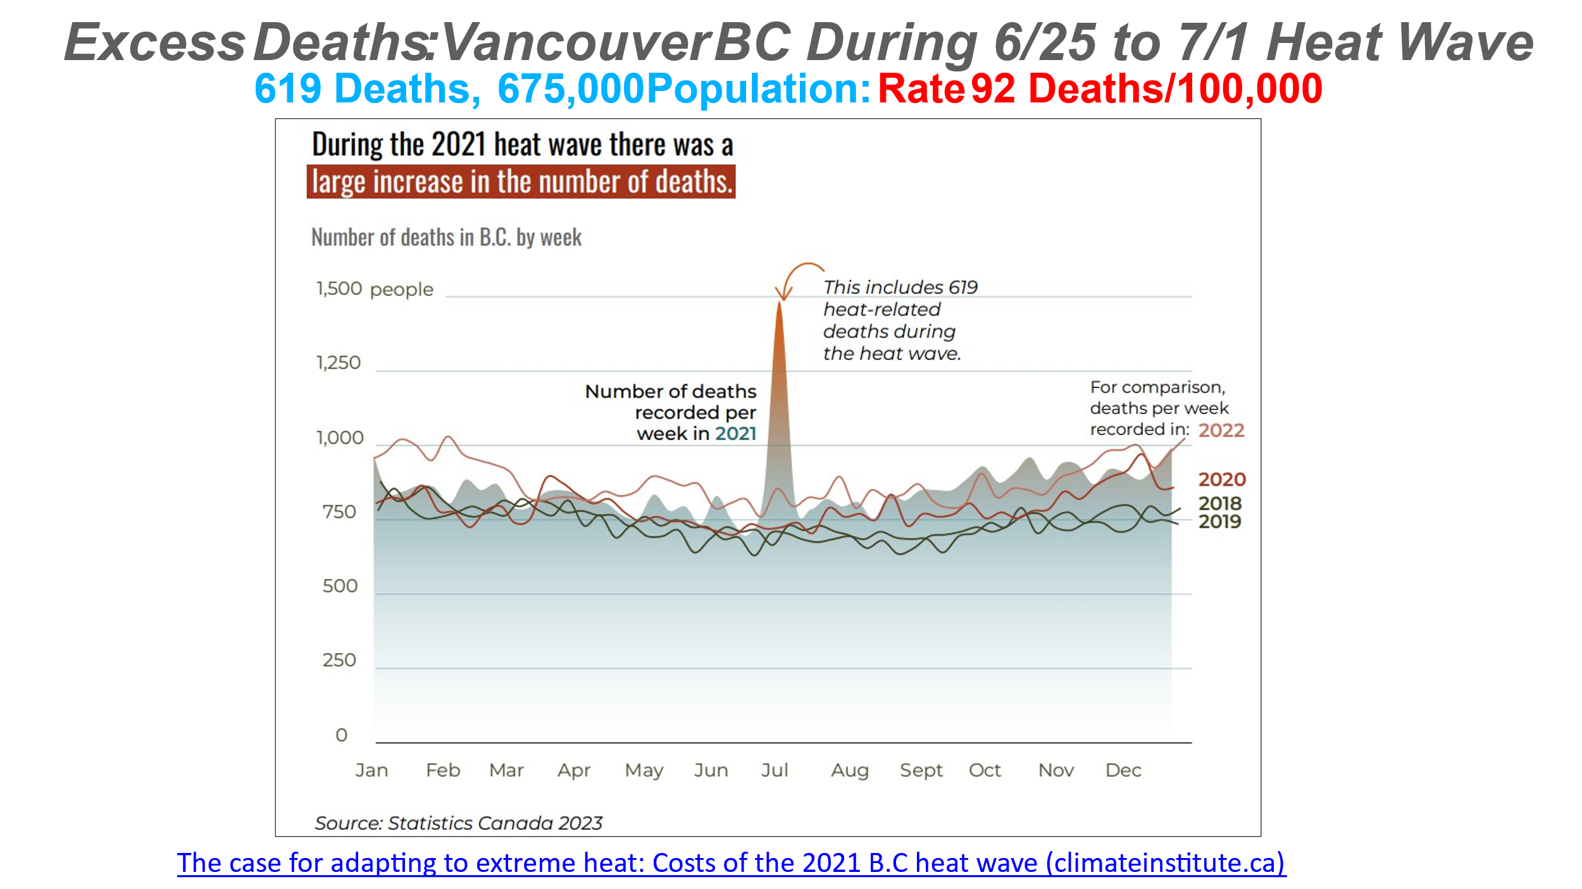

**Figure 19**: Vancouver Heat Death Spike

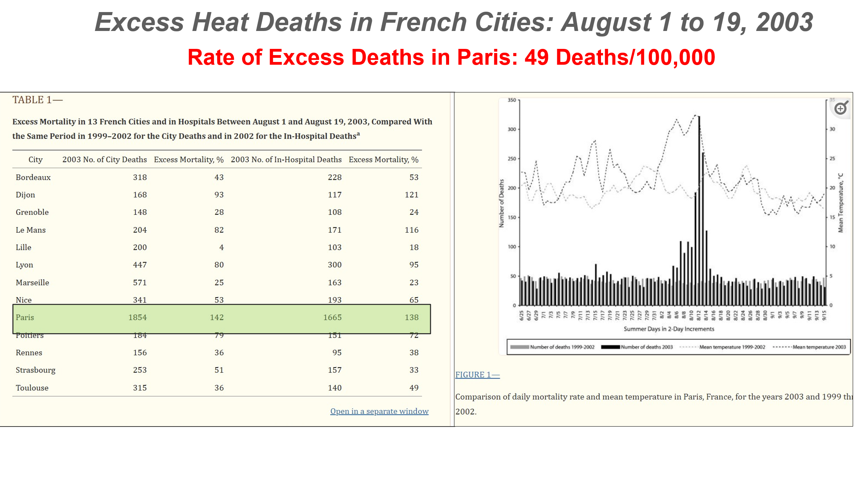 **Figure 20:** Paris Heat Death Spike [Mortality in 13 French Cities During the August 2003 Heat Wave - PMC (nih.gov)](https://www.ncbi.nlm.nih.gov/pmc/articles/PMC1448485/)

**The Heat Death Spike and Other Characteristics:** A common characteristic of the extreme heat events in Chicago, Paris, and Vancouver was a sharp spike in deaths following the initial few days of their heat waves. The steepness of the death spikes were was not matched by a proportional spike in temperatures. This led us to conjecture that it takes time for the full impact of a heat wave to take effect: gradually heating up the outside and interior environments, and relentlessly weakening vulnerable and exposed individuals. Then, with an additional small increment of heat, vulnerable individuals begin dying at an accelerating rate. We now believe that there is an inflection point based on number of days of extreme heat, and temperatures crossing a specific threshold, that results in a swift increase of illness and death. This point appears to begin at about 90 degrees Fahrenheit (33 degrees Centigrade) with humidity of about 45 percent.

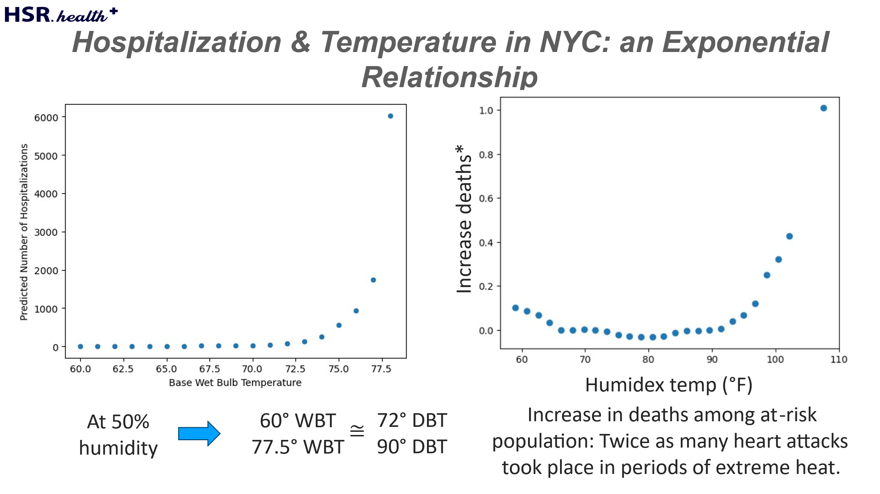

**Figure 21: Hospitalization and Temperature in NYC**

**The Arizona Exception**: Due in part to the almost universal use of AC in residences almost all Pheonix, AZ residents, except outside workers, are relatively safe from the effects of extreme heat. However, the homeless population in Phoenix is at great risk due to street level temperatures that can rise above 150 degrees. During the 2023 heatwave in Arizona, the majority of the 645 heat-related deaths occurred among the homeless population.

**Methodology for Calculating the Scale of Extreme Heat fatalities and illnesses:**

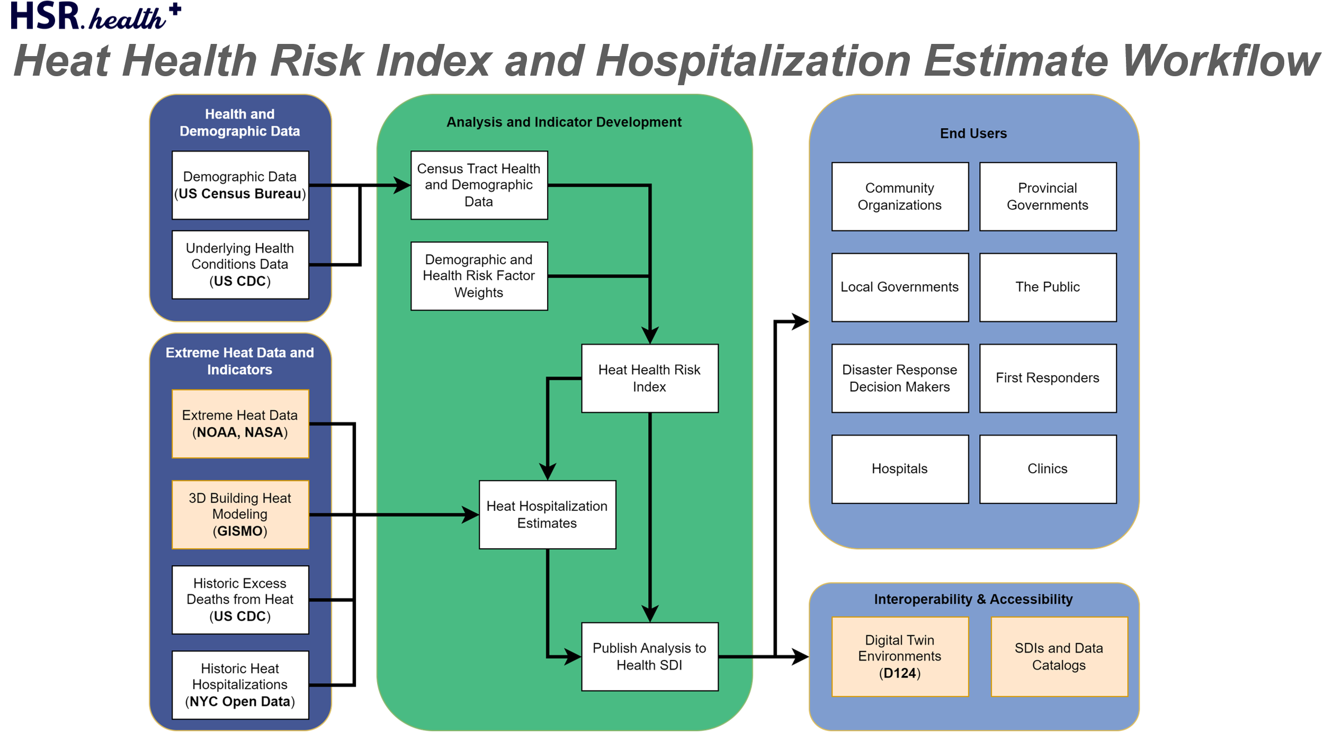

**Figure 22:** Methodology for Calculating Extreme Heat Fatalities and Illnesses

**Heat Deaths in NYC:** New York City estimates that 370 people die annually from either the direct or indirect effects of heat. (See: [Annual Report on heat mortality in NYC.](https://a816-dohbesp.nyc.gov/IndicatorPublic/data-features/heat-report-archive/2022/) [NYC’s Population Declines by 78,000 - The New York Times (nytimes.com)](https://www.nytimes.com/2024/03/14/nyregion/nyc-population-decline.html#:~:text=The%20city%20lost%20nearly%2078%2C000,which%20were%20released%20on%20Thursday.) The estimated NYC population as of 2023 is 8.25 million people.

**How Heat Deaths are Counted:** The U.S. Center of Disease Control (CDC) counts heat related deaths only when confirmed by a medical autopsy, or affirmed by a medical authority. However, this method misses many of the deaths where extreme heat was a contributing cause. As described in this PBS article ([Inconsistent methods for counting U.S. heat deaths stymie public health efforts | PBS News](https://www.pbs.org/newshour/health/inconsistent-methods-for-counting-u-s-heat-deaths-stymie-public-health-efforts)), an alternative way of counting deaths is by calculating the number of excess deaths above average for the period of time being considered. The heat death spikes illustrated in Figures 18, 19, and 20 above, are based on excess death calculations, and this method is used across Europe, in Canada, and in selected U.S. cities and counties. Sources cited in the PBS article state that it is imperative that the U.S. use the excess death measure to more accurately quantify heat related deaths, to get a truer picture of heat mortality.

**Northern Manhattan Study Area Demographics and Health Estimates**: Applying our knowledge and findings to our Northern Manhattan study area: The total population within the study area is 609,000 with 88,000 elderly, 31,000 children under the age of 5, 68,000 people making less than $25 thousand a year, 128,000 people with disabilities, and 16,000 people with chronic kidney disease.  The study area covers a total of 106 Census Tracts with many having high Heat Health Risk Index values. It is likely that the average number of annual deaths due to the effects of heat in the northern Manhattan study areas is about 27 based on Citywide estimates of 370 heat related deaths annually in NYC as a whole. (Divide by 13.5)

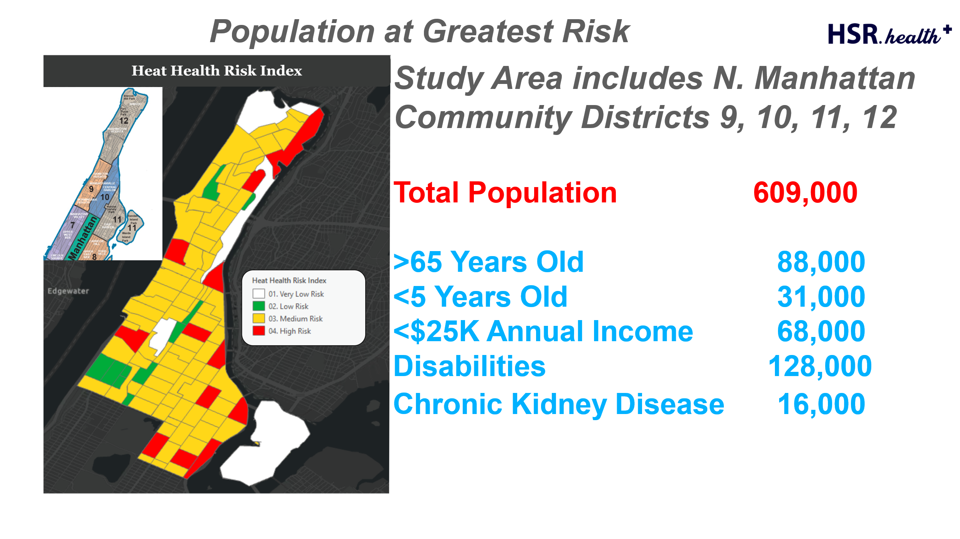

**Figure 23:** Population in Study Area At Greatest Risk

A health assessment predicts that during **Extreme Heat Scenario 1** (5 days of 100-degree temperatures but with no blackout), about 60,900 people will be exposed to temperatures with the potential to sicken them (the 10+ percent of the population without AC), and about 1,064 people will need medical treatment or require hospitalization. In addition, depending on measurement type used, excess deaths are predicted to range from between 11 and 92. .

For **Scenario 2** (Scenario 1 but with a two-day power blackout during a 5-day extreme heat event) a health assessment finds that as many as 500,000 people will experience felt temperature levels that have the potential to sicken them, and that 1,318 people may require medical treatment or hospitalization. Between 14 and 114 deaths are predicted to occur. 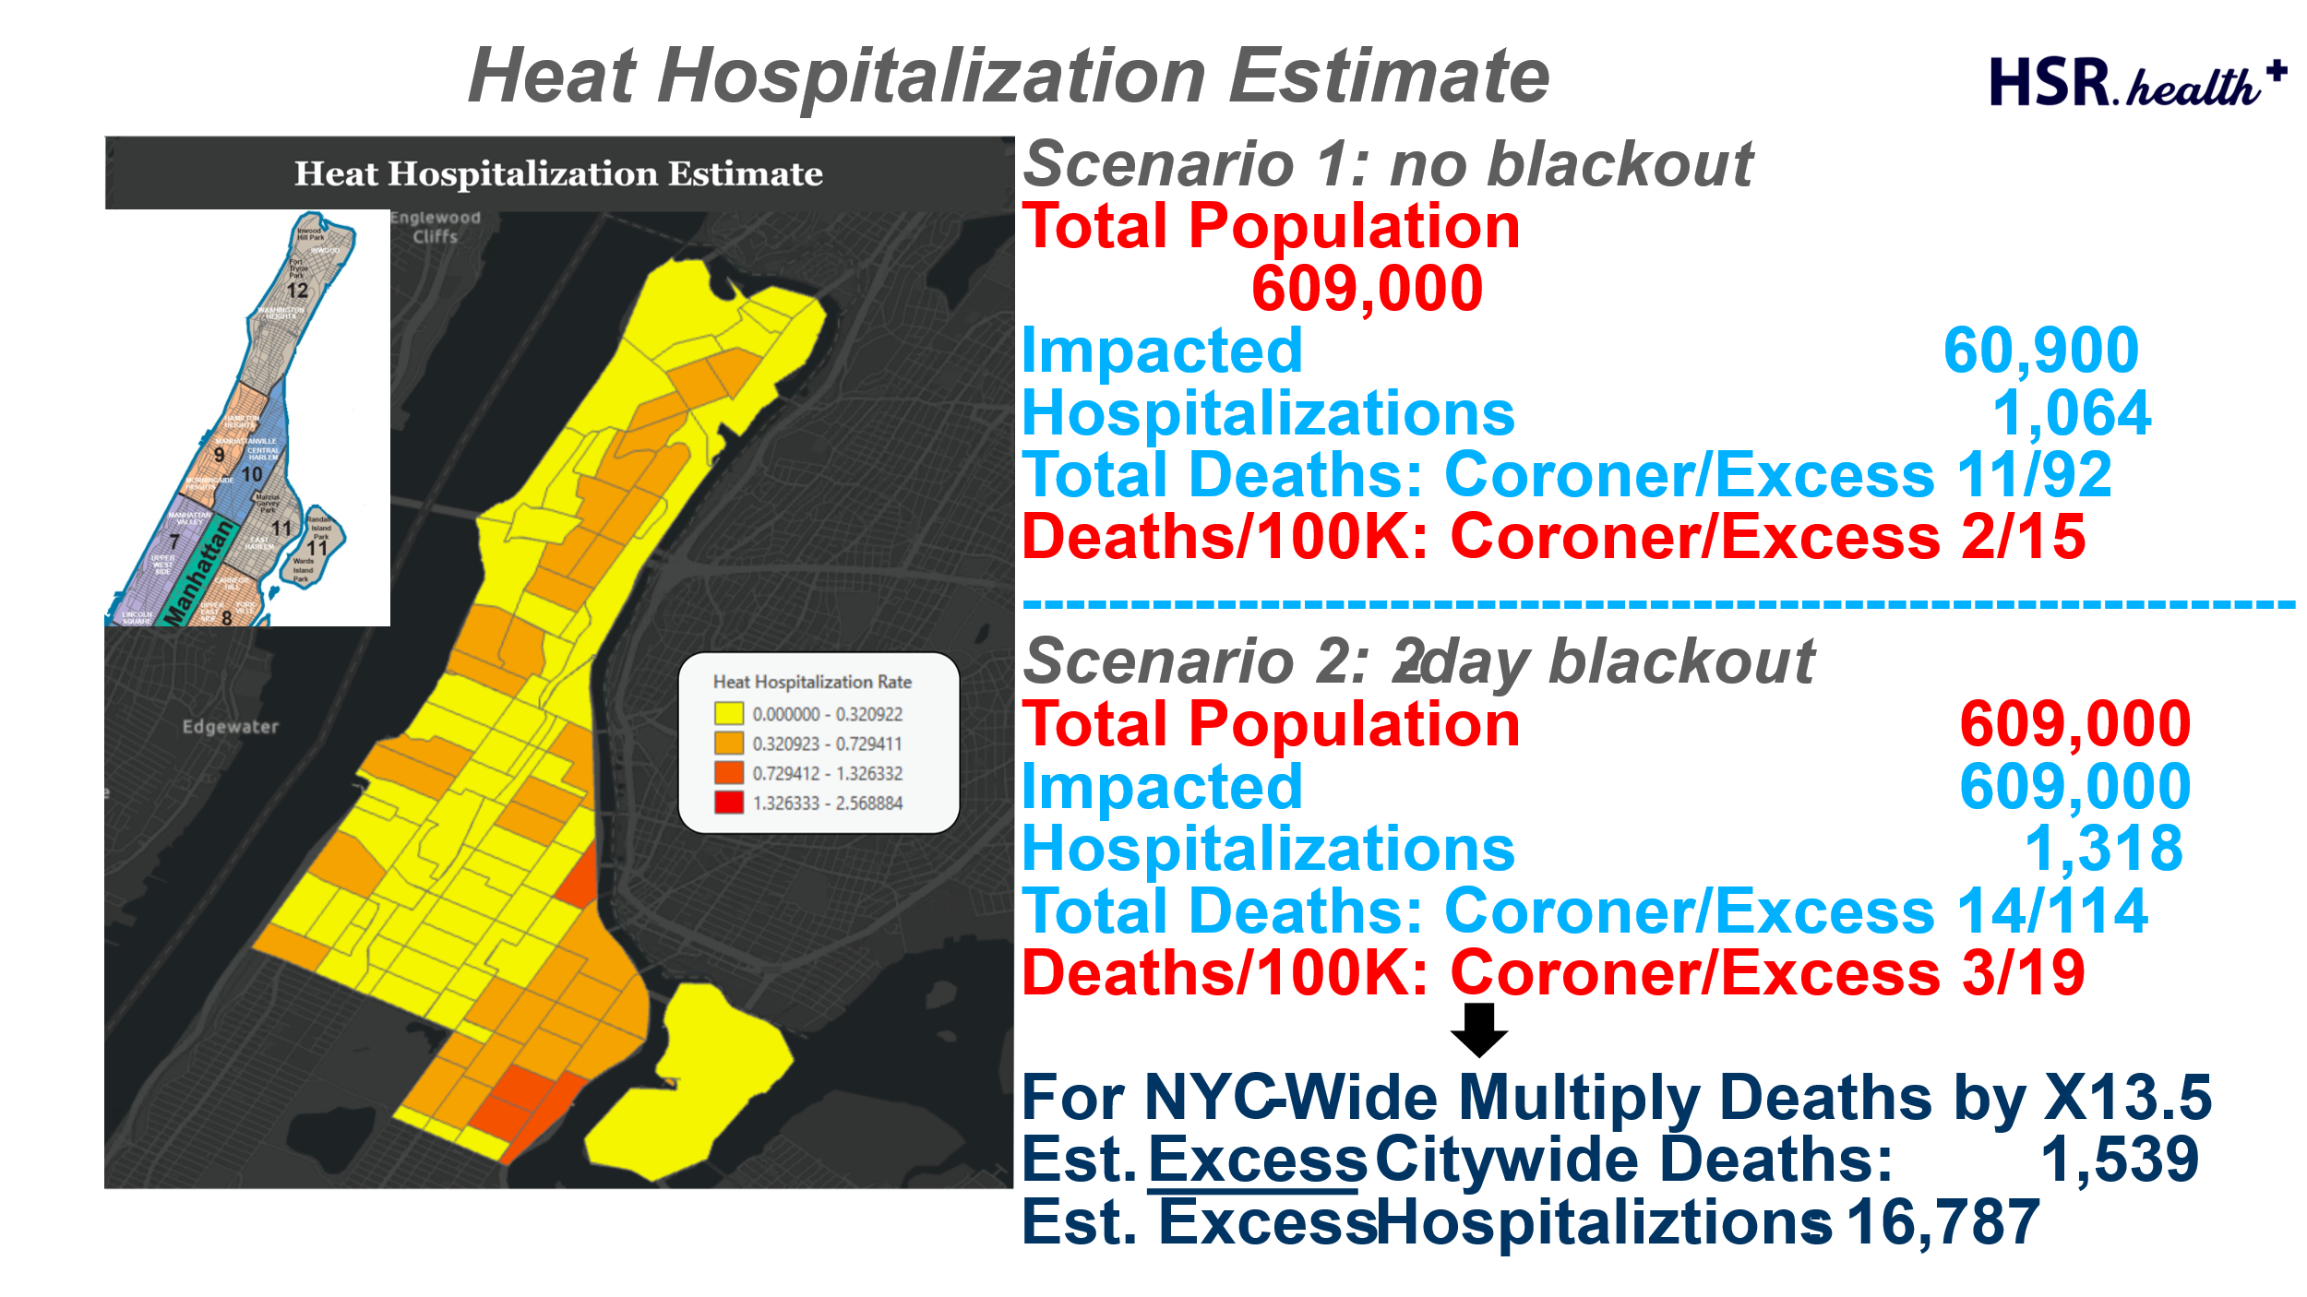

**Figure 24:** Heat Hospitalization Estimate

**Citywide Projections**: When using a straight line projection of these numbers from our study area onto NYC as a whole excess deaths and hospitalizations are estimated to be: Scenario 1: 14,364 hospitalizations and 1,242 deaths; Scenario 2: 17,793 hospitalizations and 1,539 deaths. Mortality estimates by number per 100,000 are provided in Figure 24.

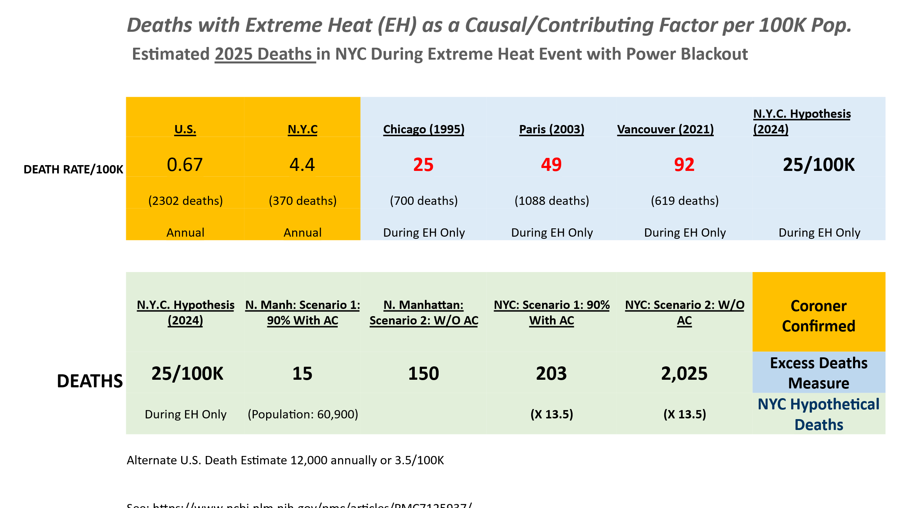

**Figure 24: Estimated Death Rates per 100K Population**

**The Urgency of Taking Fully Informed Actions**: The assessment of the two scenarios studied demonstrate that the various measures that are being taken or could be taken to prepare for and mitigate an extreme heat event must be pursued with heightened urgency and greater speed. Also see: [Rapid increase in the risk of heat-related mortality | Nature Communications](https://www.nature.com/articles/s41467-023-40599-x) for parallel findings. Also, in summary form: [Risk of heat-related deaths has ‘increased rapidly’ over past 20 years - Carbon Brief](https://www.carbonbrief.org/risk-of-heat-related-deaths-has-increased-rapidly-over-past-20-years/)

**2.7 Listing of Suggested Personal Actions**

Personal Protective Actions

* Cooling towels, Cold packs
* Emergency numbers close at hand
* Smart Phone linked to a wearable heat sensor and a room heat sensor
* A heat distress plan set up with neighbors, friends, and relatives
* Cold compresses for head, wrists, and feet
* A supply of Pedialyte or other drink providing electrolytes and hydration
* Regular cooling showers or baths
* Use refrigerator for liquids and materials that help keep you cool
* Create a cool room with AC and barriers to keep the cold air confined

**2.8 Major Findings:** Alan Leidner, NYC GISMO

The previous sections of this report lead to a number of insights and understandings about the nature of extreme heat events in the NYC study area. Most importantly, we have shown how temperature readings as currently reported can be misleadingly low, but can be improved, and how determining deaths where heat was a contributing factor can be made more complete. We have also demonstrated how temperature predictions during extreme heat events can be estimated at the street, building, and even the individual apartment level, giving the emergency response community a greater ability to target the most vulnerable during preparedness and response activities.

**More Accurate and Precise Temperature Readings**: Temperatures in urban areas depend upon many conditions and cannot be generalized across large areas. We suggest that when weather officials communicate with emergency response agencies and with the public, that they provide the temperatures experienced by people in their neighborhoods. NOAA already incorporates ambient air temperature and humidity in their heat index readings. However, for urban areas, the heat island effect must also be added. NOAA, EPA, CDC, and other Federal agencies in collaboration with state and local agencies must also study the patterns and effects of extreme heat within residences that are directly exposed to solar energy. Because temperatures experienced by the public in their neighborhoods, workplaces, and apartments can be ten to twenty degrees above officially reported temperatures, the public cannot fully understand the threat posed by extreme heat and may not prepare for these events with the urgency required. Reasonably accurate temperature estimates can now be made at the census tract, block, street segment, building, and even apartment level. To do so will be to give planners important data tools to craft preparedness, mitigation, and response strategies.

**Causes of Death**: The majority of deaths caused by extreme heat events occur inside residential spaces. Those most likely to die from these events are the elderly, and those with mobility issues, and with health vulnerabilities such as diabetes, and chronic heart, lung, hepatic and kidney conditions. Those suffering from mental health problems, and substance abusers are also highly vulnerable. In addition, the homeless who are exposed to super-heated street surfaces that can exceed 160 degrees, are also greatly endangered.

**Excess Deaths as Best Measure for Heat Events**: Deaths and hospitalizations caused by extreme heat events are best measured as excess numbers above those normally expected during average summer days. See Figures 18, 19 and 20 showing Chicago, Paris, and Vancouver extreme heat casualties. (See: [amjph00508-0117.pdf (nih.gov)](https://www.ncbi.nlm.nih.gov/pmc/articles/PMC1380980/pdf/amjph00508-0117.pdf): Mortality in Chicago attributed to the July 1995 Heat Wave by Steven Whitman, PhD, Glenn Good, MS, Edmund R. Donoghue, MD, Nanette Benbow, MAS, Wenyuan Shou, MS, and Shanxuan Mou, MS; American Journal of Public Health 1997:87:1515-1518. This article is cited by Eric Klinenberg in his book “Heat Wave.” It recommends using excess deaths above historical norms to more accurately quantify deaths caused by extreme heat events.)

**Findings Regarding Quantification of Deaths Due to Extreme Heat**: When deaths from extreme heat events in Chicago, Paris, and Vancouver were quantified based on excess deaths above the norm, excess deaths during Chicago’s 1995 heat wave were 25/100K, 49/100K for Paris’ heat event in 2003, and 92/100K for Vancouver in 2023. Each City suffered from more than 600 excess deaths. These numbers are far above those given when heat deaths are quantified based on coroner certification. These counts generally exclude deaths where heat was a contributing factor to an existing health condition. In the future, deaths during extreme heat events should be counted both by coroner confirmation and by excess deaths to ensure there is not an undercount. Undercounting extreme deaths results in a lack of public awareness of the danger and reduces the motivation to take action.

**Application to Jurisdictions Beyond NYC**: The Extreme Heat Team believes that the methods used to calculate temperature risk in urban areas, and from those calculations to derive the numbers of people likely to fall ill from a variety of different heat related ailments; can be adapted for use by any jurisdiction as long as they have available basic data layers including land use, elevation, surface reflectivity and building footprints. This will enable state and local governments to be able to scale the level of heat casualties likely to occur, identity areas where the heat threat is greatest, and to devise strategies to minimize hospitalizations and deaths from extreme heat.

**Personal Protective Strategies**: Part of any strategy to mitigate the effects of an extreme heat event, must include personal measures people can take to protect themselves. Body organs that can be particularly impacted during an extreme heat event and lead to illness include the heart, lungs, kidneys, and brain. Pre-existing conditions affecting these organs can be greatly exacerbated by exposure to extreme heat. When body temperatures exceed 108 degrees, vital human tissues begin to break down. It is vital that anyone starting to feel ill from the effects of overheating take immediate action to keep their body temperature close to normal. Methods include using cooling towels, cold packs, cooling baths and showers, drinking cold liquids. [EXTREME HEAT CAN IMPACT OUR HEALTH IN MANY WAYS (cdc.gov)](https://www.cdc.gov/climateandhealth/pubs/EXTREME-HEAT-Final_508.pdf); [Temperature Extremes | CDC](https://www.cdc.gov/climateandhealth/effects/temperature_extremes.htm); [Emergencies: Extreme Weather Heat - NYC Health](https://www.nyc.gov/site/doh/health/emergency-preparedness/emergencies-extreme-weather-heat.page)

**3.0 Recommendations:** The previously discussed findings about temperature and health during extreme heat events require us to examine the strategies being used to prepare for and respond to these events. When we take into consideration that during extreme heat events many people can be exposed to temperatures as much as 130 degrees or greater, and that measures of excess death likely exceed current estimates by a factor of five or more; we conclude that the risks are far greater than we have believed and we must respond with greater urgency to the threat of extreme heat. At the time, new mapping and analysis tools that allow the response community to know in advance the precise locations where residents will be exposed to the hottest temperatures will make it possible to customize strategies to lower risks for the most vulnerable. The remainder of this report will explore options for taking action that can mitigate the dangers of extreme heat events. These measures include:

**Electric Grid Resiliency**: The resiliency of the electric grid that provides power for life preserving AC use, is essential to minimize deaths and illness due to extreme heat events. Every means possible should be used to minimize the possibility of blackouts and brownouts which could substantially raise mortality rates. Methods can include replacing aged and obsolete transformers and other grid components, provide sources of backup power, increase grid capacity in underserved neighborhoods, and developing local sources of electric power from solar panel installations. Note the effects of Hurricane Beryl [Houstonians are sleeping in cars amid power outages after Hurricane Beryl (nbcnews.com)](https://www.nbcnews.com/news/weather/hurricane-beryl-houston-power-outage-residents-rcna161579) where loss of power has subjected 100,000’s of Texans to July’s extreme heat without the ability to use air conditioners.

**Increase Albedo of All Solid Surfaces**: Improve the reflectivity of City surfaces to decrease the amount of solar energy absorbed by built objects which add to the heat island effect. Measures can include: painting roofs with white reflective paint, increasing the reflectivity of streets and sidewalks, and planting more trees to absorb solar energy and to shade surfaces and building facades so heat does not build up.

**Keep Building Interiors Cooler**: Improve the ability of buildings and residences to minimize temperature increases due to extreme heat events by retrofitting apartments with low-e, double pane windows; window shades and drapes, special insulation for a cool room; and increasing roof and wall insultation.

**AC Gaps**: In New York City estimates that between 80 percent and 95 percent of households in City community districts have AC units. A study by the U.S. Department of Energy finds that 20 percent of households with AC units do not use them due to high electricity costs, or because the units have broken down. During extreme heat events AC units reduce interior temperatures to livable levels. This makes the possibility of a power outage extremely troubling. Cities must think through how to provide electric power to strategic locations when the grid is down. Cooling centers should have backup power generators. Battery backup is also an option for other strategic locations and can be charged by solar panels on roofs, or community solar panel arrays.

**Improving Communications for Vulnerability Individuals with Neighbors, Relatives, and the Response Community:** The OGC has explored the possibility of using the capabilities of smart phones to support individual and family safety during an emergency. In DP-23 it sponsored a study of the Emergency Location and Mapping Application (ELLA) to put endangered individuals in touch with those able to assist them.

**Improved Disaster Response:** During the early 1990’s and especially after the GIS response to the 9/11 attack on the World Trade Center, GIS capabilities have been increasingly used to prepare for and respond to disaster events. However, GIS applications able to deal with the complexity of disaster operations, are still in their infancy. This report gives a preliminary assessment of the most desirable features that need to be built into disaster oriented collaborative software tools.

**Extreme Heat Policy Measures:** Because of the way deaths from extreme heat are undercounted in the U.S., there has been less attention paid to this type of disaster than to other types such as flooding, major storms, wildfires, and tornados. However, recently it has become more generally known that extreme heat results in the highest number of deaths of any other weather-related incident type. If deaths where extreme heat is a factor are measured as excess deaths there will be greater public awareness and motivation to act more aggressively. We suggest a number of policy areas where improvements can play an important role in improve community response to these events.

**3.1 Ensuring Adequate Electric Power:** Bandana Kar, U.S. DOE

Perhaps the most important action that NYC can take in the short term to reduce the dangers of extreme heat is to lower the chances of a power blackout. Electric power to run AC units is the single most critical component of an extreme heat strategy, and is essential to preserve lives. Losing electric power, and therefore the use of AC by communities in Northern Manhattan, or NYC as a whole will jeopardize thousands of lives. To minimize the chances of a power blackout, or if there is one, to enable the rapid restoration of power, will require a close partnership between NYC, Con Edison, its electric provider; U.S. DOE, and State and Local regulatory bodies. As seen in Figure 12, NYC has experienced a number of large-scale power outages, almost all occurring during summer months.

Power grid threats during summer months include: high heat and humidity conditions causing a spike in power use, overheated distribution lines due to insufficient capacity, line sag causing electric shorts, very hot pavement temperatures causing underground cables to fail; wild fires threatening elevated transmission grid infrastructure, aging transformers and substations, cyber-attack, accidental line strike, and sabotage. (See: <https://www.coned.com/-/media/files/coned/documents/our-energy-future/our-energy-projects/climate-change-resiliency-plan/climate-change-vulnerability-study.pdf>) These challenges point to the need for frequent inspections, aggressive upgrade plans, and the development of power backup options. Also, all City residents need to consider ways to keep their living quarters, and themselves, as cool as possible during extreme heat conditions when power is not available.

Anyone without access to air conditioning (AC) during an extreme heat event – estimated to be about ten percent of the population in the study area – will be at risk. Additionally, large numbers of AC units are inoperable. Also, many households, while having functional AC units, keep them turned off due to high electricity costs. Federal, State, and City programs do provide funding to help people deal with temperature extremes (see HEAP Program: [Home Energy Assistance Program (HEAP) – ACCESS NYC](https://access.nyc.gov/programs/home-energy-assistance-program-heap/)) But while qualified individuals and families can receive subsidies to buy air conditions, much less money is available to pay the cost of the electric power they operate on.

AC prevalence within a metro area tends to be lowest among socially vulnerable population groups, such as low-income households, renters, African American and other minority households[1]. Residential space heating and cooling are major energy end uses that utilized more than 50% of energy consumption and 30% of electricity consumption in the US in 2022[2]. To reduce energy cost, in 2020, almost 27% of the US households maintained an unsafe indoor temperature[3].

The loss of electric power for the last two days of a hypothetical extreme heat event, depriving almost everyone of access to AC, could be a catastrophic occurrence resulting in thousands of casualties and deaths and particularly affecting low-income, elderly, individuals with underlying health conditions. (See: [Compound Climate and Infrastructure Events: How Electrical Grid Failure Alters Heat Wave Risk - PMC (nih.gov)](https://www.ncbi.nlm.nih.gov/pmc/articles/PMC9882910/) During such a scenario, single floor homes with minimum insulation can experience high heat impacts (Figure 25)[4]. With high humidity, the nighttime temperature can stay elevated, thereby keeping indoor temperature in the “unsafe” or “extreme caution” zone[5].

* 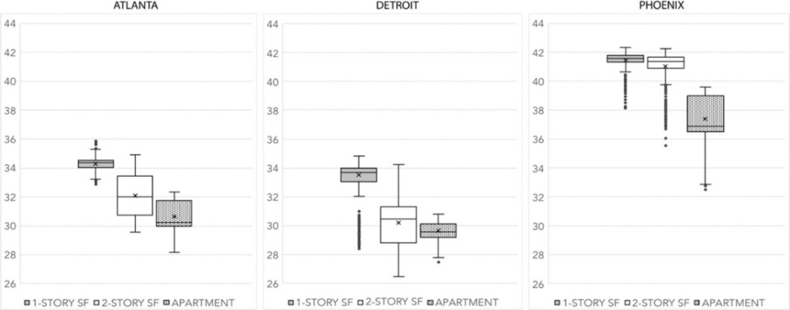

**Figure 25:** Boxplots for 5-day average maximum building-interior heat index values (°C) during a concurrent heat wave and electrical grid failure event17.

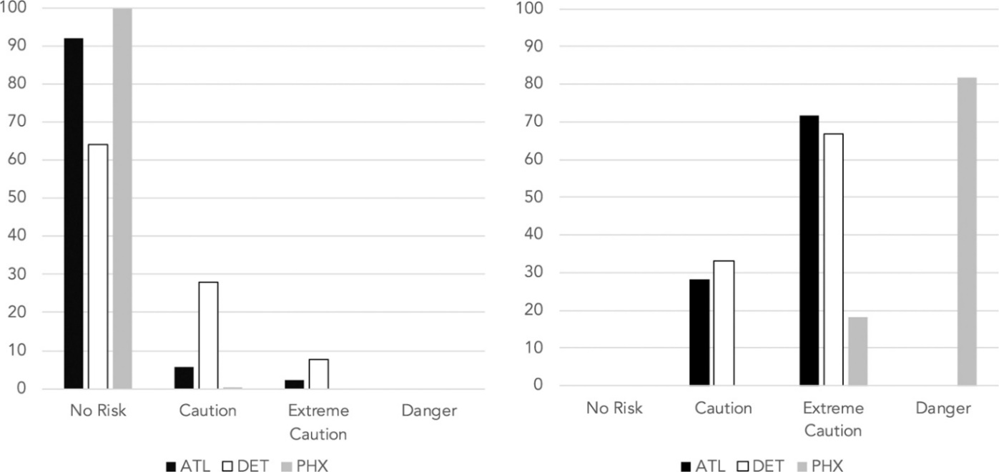

**Figure 26**: Percent (%) of residential structures categorized by heat index class during a simulated historical heat wave event (left panel) and a simulated concurrent heat wave and electrical grid failure event (right panel) 17.

The City should continue to work with its power providers to make sure that NYC electric power infrastructure is upgraded to replace aging parts in danger of overload failure; and to be in a position to rapidly repair or replace any components such as large transformers, should they fail. In their climate change vulnerability study, ConEdison[6] noted that the city’s energy infrastructures (both transmission and distribution systems) are at high risk to extreme heat events. A recent New York Times report on the use of batteries for electric storage at the neighborhood level, points in a promising direction: [Giant Batteries Are Transforming the Way the U.S. Uses Electricity - The New York Times (nytimes.com)](https://www.nytimes.com/interactive/2024/05/07/climate/battery-electricity-solar-california-texas.html) “As batteries have proliferated, power companies are using them in novel ways, such as handling big swings in electricity generation from solar and wind farms, reducing congestion on transmission lines and helping to prevent blackouts during scorching heat waves.”

While electric infrastructure hardening and alternative power generation at the grid level are underway, there also needs to be increased power generation from renewables like solar, wind and hydro. Adequate storage of generated energy on the grid side would allow demand flexibility during heat events concurrent with power outages.

Considering the aging infrastructure, having extra transformers on hand can also reduce energy risks during heatwaves. Note however, that there is a shortage of transformers across the US utilities[7].

**Local Action:** NYC should prioritize communities where the highest percentages of households are experiencing not only higher exposure to extreme heat, but also live in older homes with minimal insulation and experience high energy burden. It is these neighborhoods that may also have the oldest and lowest capacity grid infrastructure. This analysis can be supported on a building-by-building basis by using City property, building, health, economic, and demographic data which can be integrated to enable a wide variety of analytics.

The City should look into alternative power options like encouraging rooftop solar panels and battery power storage to keep at least one space within all buildings supplied with cool air. While battery storage is an option, the solution is expensive (Tesla power wall costs about $1000/KwH[8]). The city should explore thermal storage options and ground source heat pumps that can meet energy demand for cooling while reducing carbon emission.

The City should ensure access to cooling centers from neighborhoods with high concentrations of disadvantaged and vulnerable populations. Cooling centers should be equipped with backup power generators and an ample supply of fuel. With increased focus to decarbonize the energy sector and the building sector, NYC should focus on using renewables with local power storage to address the backup energy supply.

NYC should develop plans to deploy its air-conditioned bus and vehicle fleets to neighborhoods should an extreme heat event and blackout threaten large numbers of NY’ers.

The city should work with communities to take advantage of the community solar projects[9]. Community driven microgrids similar to the Brooklyn Microgrid initiative in the Park Slope and Gowanus communities could also be leveraged to meet energy demand during heatwaves[10]. [Brooklyn Microgrid | Community Powered Energy](https://www.brooklyn.energy/). Also see: [Find a Community Solar Project - NYSERDA](https://www.nyserda.ny.gov/All-Programs/NY-Sun/Solar-for-Your-Home/Community-Solar/Community-Solar-Map)

Utilities, NYC and communities should also take advantage of the Connected Communities Funding Program from the Dept. of Energy[11] to create grid edge solutions that are deployed on the customer end to meet energy demand and mitigate extreme weather impacts by expediting recovery time following outages.

**3.2: Reducing Solar Absorption in Neighborhoods and Living Spaces:** Jiin Wen, NYC GISMO

Older people make up the majority of those who die of extreme heat, and many of those individuals die in overheated apartments that do not have functional AC units. [The deadly threat of a sweltering apartment | PBS NewsHour](https://www.pbs.org/newshour/health/deadly-threat-sweltering-apartment); [Takeaways about heat deaths and vulnerable older people | AP News](https://apnews.com/article/extreme-heat-deaths-aging-climate-47a8089cdecc84a0f19697438975353f) . Additionally, U.S. DOE has found that of those who do have AC systems, twenty percent do not use them due to the cost of electricity needed to run them. (need citation) An essential strategy to deal with extreme heat events is to implement ways of reducing heating on City streets and in City buildings and apartments. Many of these strategies are well known but the urgency with which they are implemented needs to be increased. For reference purposes please take a look at the Extreme Heat plans of New York State and New York City: [Extreme Heat - NYSDEC](https://dec.ny.gov/environmental-protection/climate-change/effects-impacts/extreme-heat); [Extreme Heat Adaptation - NYC Mayor's Office of Climate and Environmental Justice (cityofnewyork.us)](https://climate.cityofnewyork.us/initiatives/extreme-heat-adaptation/#:~:text=To%20combat%20extreme%20heat%2C%20the,investing%20in%20social%20resiliency%20programs.); [Plan for Hazards - Extreme Heat - NYCEM](https://www.nyc.gov/site/em/ready/extreme-heat.page)

**Strategies for Streets and Sidewalks and other street level paved surfaces**: New York City and many other cities have programs to reduce street level temperatures, including tree plantings and increasing the number and area of green spaces. NYC has a large-scale street tree program that plants more than 15,000 trees annually. New York State also has a large-scale program. If half of NYC streets were shaded by mature trees the UHIE could be reduced by two degrees or more. As streets and sidewalks are treated to be more reflective, additional temperature reductions are possible.

**Heat Resilience for Buildings:** There are a number of well-known strategies for reducing the Urban Heat Island Effect.One of the cheapest and easiest is painting rooftops white to maximize solar reflectivity and reduce heat absorbed into top floor apartments. New York City reports that 15,000,000 square feet of rooftop have been painted [NYC CoolRoofs](https://nyc-business.nyc.gov/nycbusiness/business-services/incentives/nyc-coolroofs). However, in NYC as a whole there are about 54 square miles of rooftop area with each square mile the equivalent of about 25,000,000 square feet. [PowerPoint Presentation (nyc.gov)](https://www.nyc.gov/assets/dep/downloads/pdf/water/stormwater/dep-citywide-parcel-based-impervious-area-study-presentation.pdf) Given these numbers, the City’s current white roof program has thus far addressed about 1.1 percent of the rooftop area in the City. This program should be accelerated. Painting all City roofs white could drop the UHIE by several degrees.

**Solar reflective film on Windows**: Low-e treatment of south and southwest facing windows can reduce interior apartment temperatures and is reported to reduce interior apartment temperatures significantly. Most expensively, windows can be replaced by new ones built with highly reflective low-e glass. The lower cost solution would be putting a transparent, reflective film on existing windows along southeast, south, and southwest facing building facades. Roof solar panels in combination with white roofs may be an option. Green roofs can also be considered. In some instances, especially in older, poorly built buildings, more extensive renovations to add insulation to walls and ceilings, and providing for improved ventilation, may be warranted.

**Other Heat Protective Strategies for Residences:** With the help of instructive videos, City residents can be shown how to establish a cool room in their homes and apartments in which they can shelter during extreme heat events. Such a room should be set up to be isolated from warmer apartment areas. Even a simple bedsheet hung on cool room doorframes can help keep cool air in and hot air out. LED lightbulbs can be installed to reduce the heat produced by less efficient light bulbs. When humidity levels are below 50 percent, low cost, low energy evaporative coolers may be helpful [Evaporative Coolers | Department of Energy](https://www.energy.gov/energysaver/evaporative-coolers). The City should consider sending teams of trained personnel and volunteers to advise residents of measures they can take within their living spaces, to better protect themselves from extreme heat. (See: [NYC CERT- NYCEM](https://www.nyc.gov/site/em/volunteer/nyc-cert.page), the City’s Community Emergency Response Team Program). Funding or financing should be provided by the City as needed, to support the purchase of the materials and equipment required. Support for electric costs should be provided so that residents do not feel it necessary to shut down their AC units due to high electric costs.

The above are only a handful of strategies that NYC and other cities can employ. Newer technologies such as local electric storage and heat pumps may be used effectively. The city should review the following directives and programs from the U.S. Department of energy Building Technologies office:

<https://www.energy.gov/eere/decarbonizing-us-economy-2050-national-blueprint-buildings-sector>

<https://www.energy.gov/eere/affordable-home-energy-shot>

<https://www.pnnl.gov/sites/default/files/media/file/ABC%20Research%20Opportunities%20Report%202023.pdf>

**3.3 Improving Communications:** Theo Goetemann, Basil Labs

Studies of survival rates in communities experiencing extreme heat events (See: “Heat Wave” by Eric Klinenberg: [Heat Wave: A Social Autopsy of Disaster in Chicago, Klinenberg (uchicago.edu)](https://press.uchicago.edu/ucp/books/book/chicago/H/bo20809880.html) , demonstrate that the ability of vulnerable individuals to be in regular touch with family, friends, and neighbors can be essential for their survival. Universal use of simple smartphones may provide a solution. Such devices not only make communications easier, but can also be connected to third-party sensors, including wearables, and apartment/home sensors to monitor the living environment of vulnerable individuals. If sensor data is routed through a mobile phone application, warnings of high body or room temperatures can be used to alert family, friends, and emergency response teams operating in the neighborhood. Given user or administrator-set thresholds, alerts or calls for assistance can be triggered automatically based on a number of pre-determined criteria including previously submitted survey information that is enriched with building and apartment location data.

In OGC Disaster Pilot-23, Basil Labs designed and developed a prototype for an Emergency Location and Language Application (ELLA) for Manitoba Emergency Management Organization and Natural Resources Canada (See section 6.11 [Engineering Report for OGC Disaster Pilot 2023](http://ogc.pages.ogc.org/DisasterPilot2023/documents/D001-Summary_ER/document.html#_52f3914c-2c58-4b57-9b95-9afdf5eace07)). The ELLA application successfully demonstrated that a smartphone application, connected to the cloud, and augmented by AI and Large Language Models (LLMs), could take voice input, geolocate it, translate it into a common language, covert the input into text, and analyze that text to identify key themes and priorities. Although an ELLA prototype was not developed for DP-24 we are comfortable saying that a similar, citizen oriented, user- friendly data gathering and analysis platform could be developed for vulnerable individuals at high risk from extreme heat. Features of such an application could include connections to room environmental sensors, connections to wearable devices to monitor personal health indicators like body temperature, capture, analysis, and priority ranking and locating voiced and texted messages sent to the responder community based on urgency and proximity; and the maintenance of constantly refreshed maps of distress levels across an entire jurisdictions for situational awareness (SA). ELLA can serve as a supplement to 9-1-1 and 3-1-1 systems which can be stressed during a large-scale extreme heat event and other disaster types as well. ELLA can also be integrated with new Collaborative Emergency Management Software discussed in the next section.

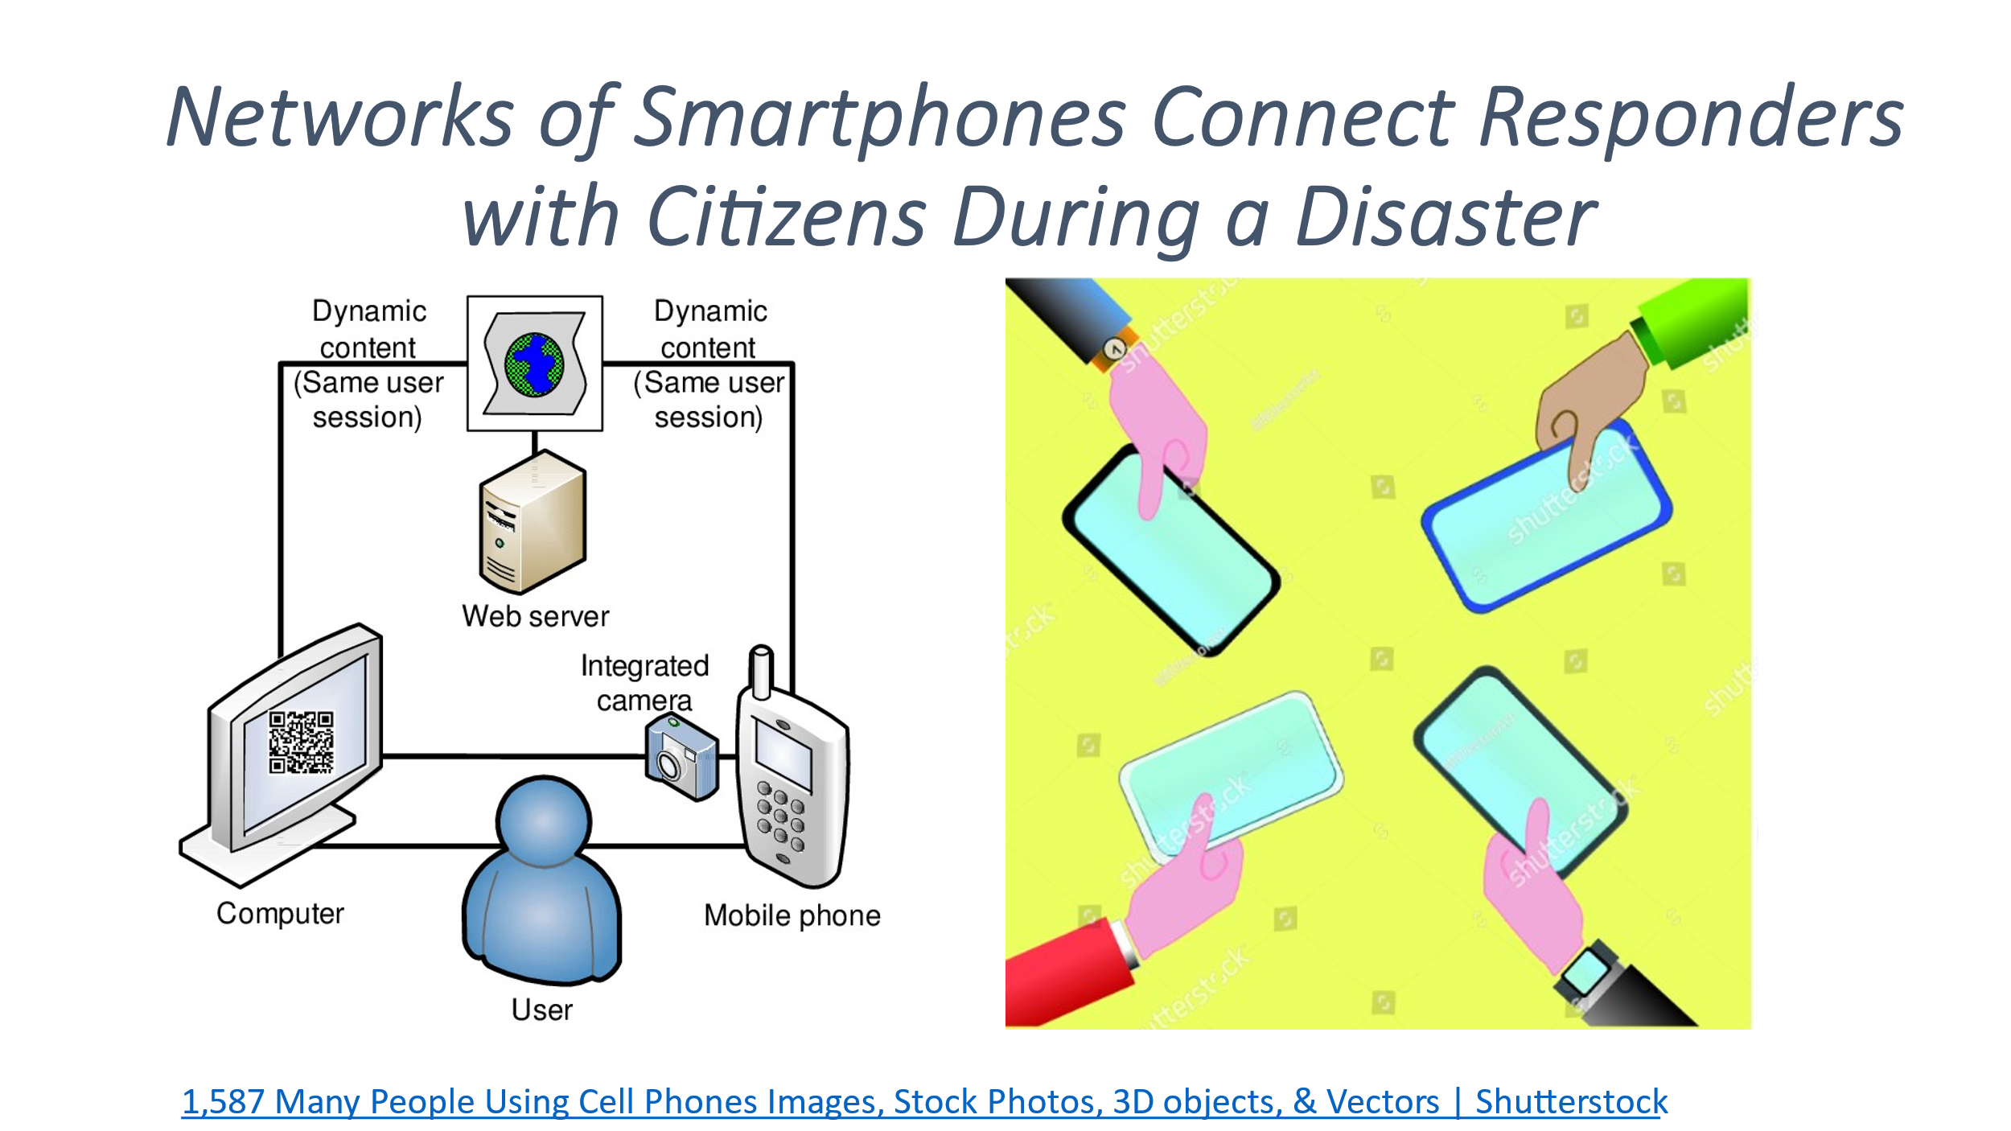

**Figure 27:** Communications Between Responders and Citizens Using AI

**3.4 Collaborative Software:** Josh Lieberman, Tumbling Walls

Should an urban area experience an extreme heat event complicated by a power outage, almost all residents will be threatened with serious illness and death. In such instances, calls for help will likely stress the City’s 9-1-1 and 3-1-1 systems, while the hundreds of emergency teams working in communities will lose touch with incident commanders and those at greatest risk. To properly react requires coordination with hundreds and perhaps thousands of responders who will include police, fire, EMS, and health department teams. At the same time other City, State, and Federal agencies, utilities, aid organizations, community groups, and private firms will need to coordinate their activities and to maintain a grasp on the overall disaster situation. Additionally, each FEMA/NIMS Emergency Support Function (ESF) must effectively coordinate its activities across related activities of other ESFs. Furthermore, it is critical to engage individuals “on-the-ground”, in continuous, near real-time feedback loops to 1) collect community-related data, 2) quickly analyze insights and reports, 3) provide current information to the public regarding actions and precautions they can take to keep safe, customized to their locations. These complicated response requirements often exceed the ability of current urban emergency support systems. Only innovative artificial intelligence methods can possibly handle the large number of needed reporting and response transactions during the short window of opportunity (the “golden” hours) to save the lives of individuals becoming ill from the heat.

Collaborative software is now available, that is using advanced analytics and AI, to better manage large scale disaster events, by being able to receive, translate, interpret, and route huge volumes of status reports, analytics, and decisions. Extreme Heat project participants are talking to Compusult, StormCenter, and other companies that provide this type of software. In the near future, we expect to provide guidance on the features to be looking for when shopping for this kind of solution. Collaborative software, which can be integrated with applications like ELLA, to manage field communications can at last give the response communities the tools they need to maintain situational awareness and create the different kinds of common operating pictures (COPs) needed to manage large scale, complex events of all kinds.

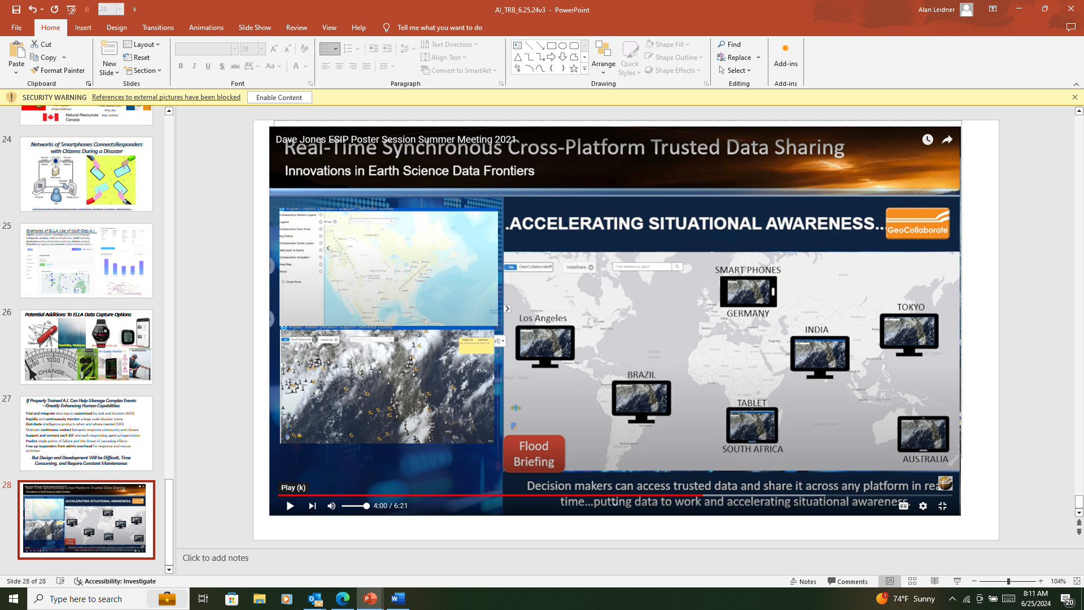

[Dave Jones ESIP Poster Session Summer Meeting 2021 (youtube.com)](https://www.youtube.com/watch?v=b5E0N0P51IM&t=245s)

**Figure 27:** Use Of Collaborative Software To Manage Complex Disaster Responses

**3.5 Policy Recommendations:** Alan Leidner, NYC GISMO

Governments at Federal, State, and Local levels have already worked to prepare for extreme heat events. The NWS has done an amazing job of developing the science of extreme heat, and being able to predict heat events days and weeks before they actually occur. NOAA and CDC have recently launched a new Heat.gov website. (See: [HEAT.gov - National Integrated Heat Health Information System](https://www.heat.gov/)) Many state and local agencies have websites with instructions for their jurisdictions about how to deal with heat. However, there are some policy areas that can be improved.

**Adjust Temperature Readings and Predictions To Reflect the Heat Island Effect**: At the present time NOAA recognizes the existence of the heat island effect, but does not fully include such measures into its forecasts and predictions. Consequently, NWS may predict a series of 100-degree days without mentioning that in urbanized residential neighborhoods with a high percentage of low reflectivity (low albedo) paved and built surfaces, the actual felt temperature can be between ten and twenty degrees higher than the measured temperature when felt humidity levels (Heat Index) are also factored in. This difference between publicly announced temperature readings and the temperatures that are experienced by individuals on the street and in their homes, can result in the public and the emergency response community underestimating the level of risk. When NOAA lets government officials, emergency response leaders, and the public, know the actual level of heat and its dangers, it can lead to better preparedness and response.NOAA should expand its CAPA program that measures the temperatures across urban areas, and add temperature measures from within solar exposed residences.

**Adopt a Standard, Most Accurate Way of Measuring Excess Heat Deaths:** Deaths from extreme heat events are currently calculated on the basis of reports by medical authorities. However, this method often excludes many deaths where extreme heat was a contributing factor. An alternative way of estimating extreme heat deaths is measure excess deaths above historic norms. When “excess death” measures were made for Chicago (1995), Paris (2003) and Vancouver (2021) the rates of death per 100,000 people was 25/100K, 49/100K, and 92/100K respectively. The Center for Disease Control should assess this and other measurement options. It may be that having several ways of measuring heat deaths and hospitalizations will give a more complete picture of the dangerous effects of extreme heat not dissimilar to combining multiple storm models to arrive at a consensus prediction.

**National Spatial Data Infrastructure to Support Precision Measures of Heat at the Census Tract, Street, Building, and Apartment Level:** The 9-1-1 Emergency Response System saves thousands of lives annually, and depends upon the rapid dispatch of responders to an exact incident location. Knowing who is in distress and the nature of their condition is essential for effective treatment on the scene and quick transportation to an appropriate medical facility. Extreme heat events and other disaster types are like 9-1-1 emergencies only on a far larger scale. Yet even during a disaster, saving a life often comes down to a nearby response team knowing exactly where to go, how to get there as quickly as possible, and knowing in advance a victim’s medical condition. The National Spatial Data Infrastructure (NSDI) strategic plan should set as a goal the development of local data that enables emergency responders, in a large-scale disaster situation, to have an accurate location data foundation including street names, addresses, coordinates, and even apartment numbers. The National Emergency Number Association (NENA) has long been a leader in setting location standards for 9-1-1 dispatch operations including its New Generation (NG) 9-1-1. [NG9-1-1 Project - National Emergency Number Association (nena.org)](https://www.nena.org/page/ng911_project)

**Information Privacy:** HIPAA legislation provides for the protection of private, health information which is important to guard against abuse of this information. However, these restrictions can impede the ability of the City to collect information about personal health conditions essential for effective emergency response. This information can be essential to help protect and save the lives of individuals during disasters such as extreme heat events. During the early years of the COVID pandemic the reluctance of public health agencies to collect and use personal information about location, vulnerabilities, and illness made it hampered the ability to track the spread of COVID, and to intervene effectively in the neighborhoods most affected. There should be no hesitation in allowing health professionals to acquire and use personal information to help manage events that threaten public health, as long as appropriate security measures are in place to protect the data. (See: [Health Spatial Data Infrastructure Concept Development Study Engineering Report (ogc.org)](https://docs.ogc.org/per/21-021.html) Section 5.2.2 Population and Patient Data) Many if not most individuals would want their personal information to be made available to emergency responders since it could save their lives. Individuals should be given the option and the means of making their information available with the assurance that their data would be protected.

**The Home Energy Assistance Program (HEAP):** The HEAP program provides funding for eligible New Yorkers to help pay for heat in the winter and cooling in the summer. Such as the purchase of AC units. However, HEAP does not pay for associated electricity costs. Consequently, many people limit or discontinue use of AC even during a heat wave. Federal, State, and Local government agencies need to find a way to provide funding to help pay down summer electric bills to ensure that AC units are used to protect those who are less affluent. (See: [Amid Heat Wave, Eligible New Yorkers Can Apply for State’s Air Conditioner Subsidy—For Now (citylimits.org)](https://citylimits.org/2024/06/18/amid-heat-wave-eligible-new-yorkers-can-apply-for-states-air-conditioner-subsidy-for-now/)

**Update the GeoCONOPS**: Geospatial Information Systems, certainly since the highly effective GIS response to 9/11, are considered essential to support all phases of the emergency/disaster life cycle, especially preparedness and response. Developing and applying GIS capabilities are specialized skills which many Information Technology (IT) executives do not possess or fully understand. The Geospatial Concept of Operations document prepared by the Federal Emergency Management Agency (FEMA) of the Department of Homeland Security, (See: [GeoCONOPS (arcgis.com)](https://geoconops-geoplatform.hub.arcgis.com/) was developed as a guide to the best uses of spatial capabilities to support disaster operations. Effective GeoCONOPS identify state-of-the-art applications, techniques, and technologies. GeoCONOPS can show the entire emergency response community, the value GIS managers and practitioners can provide. The GeoCONOPS has not been revised for a number of years during which GIS practices have significantly improved. For example: The GeoCONOPS should have a chapter addressing every Emergency Support Function (ESF) describing, in detail, how geospatially enabled capabilities can be utilized. Guidance of this kind cannot be found in either the National Incident Management System (NIMS) or the National Response Framework (NRF). The GeoCONOPS should also be updated to reflect the latest GIS advances in artificial intelligence and the use of sensor technologies. Having the geospatial response to extreme heat covered by a section of the GeoCONOPS would greatly advance the way we deal with these deadly events.

**Make Extreme Heat a Stafford Act Eligible Disaster Event**: Although extreme heat kills and sickens more individuals than any other weather-related event, such as flooding, violent storms, and drought, it is not a Stafford Act eligible disaster. Consequently, preparing for, mitigating, and responding to extreme heat events receives less Federal funding that other less deadly disaster events. The National League of Cities and others have introduced Congressional legislation to make extreme heat Stafford eligible. [Weather Related Fatality and Injury Statistics](https://www.weather.gov/hazstat/)

Note that heat related deaths depicted below would be much higher if calculated on the basis of “excess” deaths.

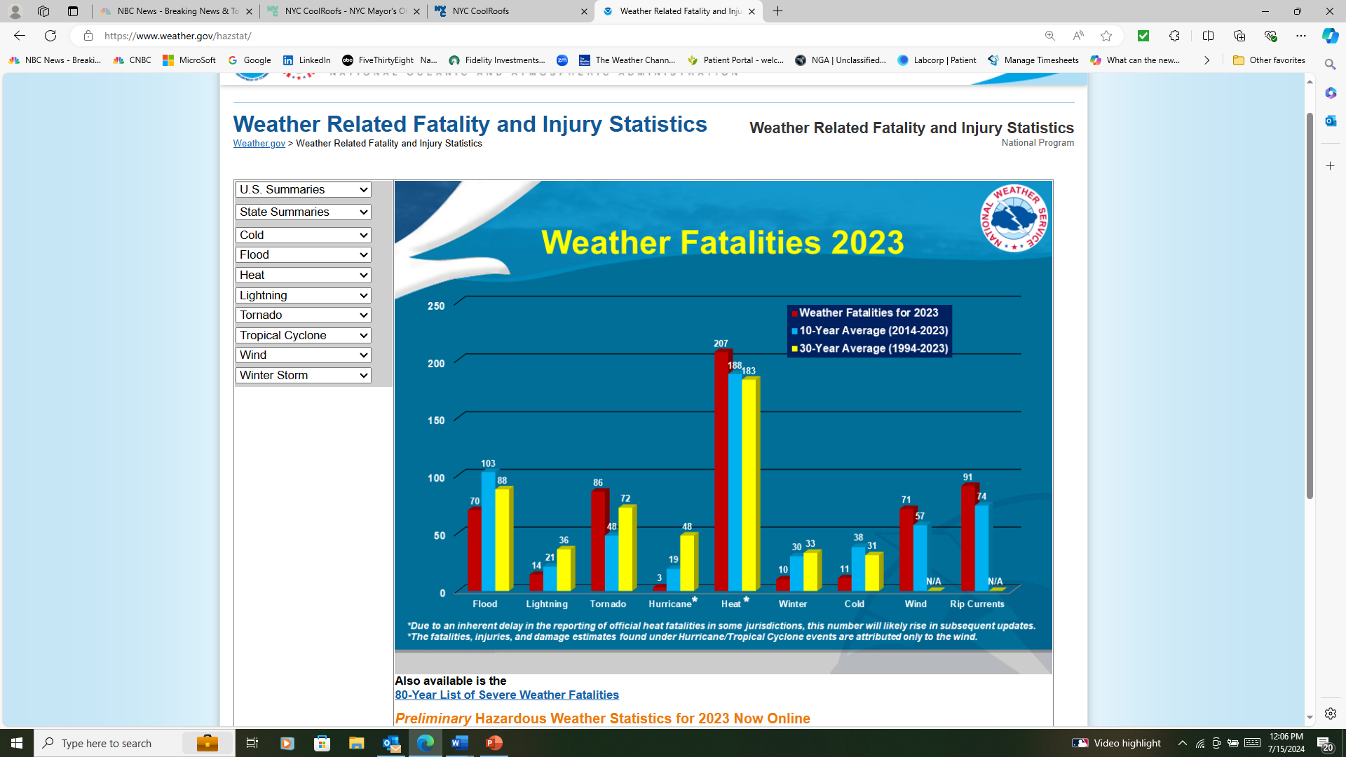

**3.6 Conclusions**

**We have learned significant lessons:** We now have a better understanding about the different components of the heat layer cake, which allows us to estimate the true temperatures that people living in urban areas are exposed to. We also understand how to improve our ability to count deaths and hospitalizations where extreme heat is either the dominant or contributing cause. The combination of these two factors will increase the insight and urgency with which we address extreme heat events. We have also come to understand the ability to, and the importance of precision mapping of heat exposure and personal vulnerability to the street, building, and residence, for faster and more effective preparedness and response.

**Next Step – Develop a Prototype Heat and Health Application**: At this writing, HSR.*health* is leading an effort supported by NYC GISMO, Climate Central, Safe Software, OGC, and USGS to create an application that can be customized for use in any urban jurisdiction to better predict the effects of an extreme heat event. It is expected that this application will lead to operations design and policy decisions that will more effectively mitigate the effects of these deadly events.

**We thank** OGC and DP-24 project sponsors for supporting this Pilot Project

**Questions Requiring Future Work:** We strongly recommend continuing our efforts on extreme heat in future iterations of OGC’s Disaster Pilot Program. We suggest that these efforts should focus on answering the following questions:

* How can we measure reductions in the urban heat island effect made possible by increasing surface reflectivity and expanding green areas? Being able to demonstrate the effectiveness of strategies to reduce urban heating will accelerate their adoption.
* How can collaborative software including packages from Compusult and StormCenter improve emergency preparedness and response to extreme heat events and other disasters? The use of collaborative disaster management software that takes advantage of artificial intelligence, machine learning, and advanced sensor technologies will make disaster preparedness and response activities more effective.
* How do interior apartment temperatures vary by their exposure to solar energy? How effective are apartment and building materials such as white roofs, reflective facades, LCD light bulbs, reflective windows, and interior insulation; in keeping temperatures down?
* What is the right combination of sensors, protective actions, and communications to improve the safety of vulnerable individuals. Extreme heat is the biggest killer of all the weather-related disaster events. We have an obligation to better protect people from its deadly effects.
* What effects will the increasing intensity of urban heat waves have on above and below ground infrastructure that is sensitive to high temperature, and how can these effects be mitigated. We already know that extreme heat has a deleterious effect on electric and telecommunications lines, and that steel rails and structures can warp when subjected to excessive heat. [Busiest transit hub in U.S. rocked by days of delays amid heat wave (nbcnews.com)](https://www.nbcnews.com/news/us-news/busiest-transit-hub-delays-heat-wave-rcna158318)
* Can atmospheric aerosols that reflect solar energy away from the earth be used in limited amounts to mitigate the effects of heat domes and other weather phenomena that can cause extreme heat events, without damaging the environment?

**4.0 Appendices**

**Appendix A: Leveraging Official Death Certificates for Heat-Related Mortality**

Ajay K Gupta, HSR.*health*

There is concern that low numbers of deaths officially ascribed to “excess heat” may paint a picture where rising temperatures are not a potential killer and thus not a major problem deserving of intervention. This stems from the cause of death classification on official death certificates and the National Death Index. Typically, “heat stroke” and/or “heat exhaustion” is likely only assigned as the primary cause of death in patients who do not have any other medical conditions as a diagnosis of exclusion. Limiting deaths to the primary cause may not be advisable when it comes to assessing the impact on health outcomes from prolonged exposure to extreme heat. The challenge is that official death certificates may not be designed to capture the degree to which heat contributed to patient mortality.

Currently, there is no objective and standardized methodology to classify the contribution from heat exposure to the medical issue that led to death. Clinicians in the United States are – purposefully – constrained regarding what they can write on death reports as the primary cause of death. If an individual succumbs to Ischemic heart disease brought on by exposure to heat, it is important to recognize the heart condition as the primary cause of death – and also important to recognize the contribution the heat exposure played in bringing on a fatal cardiac event. By recognizing the interaction of both factors, clinicians, health systems, communities, as well as individual patients will be in a better position to serve their medical needs.

Similarly, patients with chronic conditions such as COPD or renal failure will only have excess heat as a contributory cause if it’s recognized at all as a causative factor. Perhaps in addition to a contributory cause field on death certificates, such causes can be labeled as “precipitating”? This is at the heart of why heat death counts show such variability. ([NYC, EH Data Portal, 2022 Heat-related Mortality Report](https://a816-dohbesp.nyc.gov/IndicatorPublic/data-features/heat-report-archive/2022/)). In this regard, it may be better to think of excess heat like air pollution. The World Health Organization (WHO) and the majority of public health organization recognizes the deadly effect of air pollution. A recent WHO report states that air pollution is responsible for 13 deaths every minute across the planet. (WHO, Health Consequences of Air Pollution on Populations, June 2024). However, air pollution is rarely listed as the ultimate cause of death. Instead, respiratory failure secondary to COPD exacerbation, hypoxia secondary to asthma attack, or similar, is listed even though these events were likely activated by excessive air pollution. No researcher or health professional would deny that air pollution played a major factor in these deaths.

Until additional guidance, such as from the WHO or CDC, is provided on the issue of heat-induced or heat-contributed deaths, it remains important to use both official death certificate information (with heat as the primary and contributory cause), as well as a calculation of excess deaths. This approach will better convey the overall risk. A geographic area or population that is recognized as being at risk for excessive heat harm is at risk from both direct deaths as well as deaths from chronic conditions that are worsened by prolonged heat exposure.

**Appendix B: Emergency Location & Language Application (ELLA)** TheoGoetemann, Basil Labs

**AI-Augmented Surveying**

Today, the potential to receive rich data from large numbers of on-the-ground respondents and process it in near real-time is closer than ever. In DP23, the GISMO team, including Theo Goetemann of Basil Labs, showed the potential of ELLA (Emergency Language and Location Application) — a survey platform with multi-lingual voice note and geolocation features. This application could be particularly valuable in extreme heat and other disaster scenarios, where timely and accurate information from victims can enhance situational awareness and decision-making for emergency responders.

ELLA's goal is fundamentally to incorporate AI as a core building block in order to maximize information inflow from residents and field responders. Core features that differentiate the platform from others include multilingual voice note surveys, which encourage respondents to voice what they want in the language they are comfortable with, geolocation of the respondent, LLM-enabled topic classification of open responses, and REST API and GeoRSS integration to enable analysis further downstream; community-informed spatial awareness combined with rich, open-ended yet quantified and categorized feedback.

**Continuous Communication with Residents and First Responders**

Effective disaster response relies heavily on robust communication channels between residents and first responders. Platforms like ELLA can facilitate two-way communications, allowing residents to report their conditions and needs while responders provide real-time guidance and updates. This dynamic interaction helps manage and mitigate the impacts of extreme heat events by ensuring that resources are allocated efficiently and that help reaches those who need it most.

The implementation of these communication channels can be additive rather than zero sum, contributing to the efforts of 9-1-1, municipal, 3-1-1, and other communication systems. In particular, a platform like ELLA offers augmented capabilities to quickly deliver the right information to the right individuals. If an individual self-reports that they have a low tolerance for heat and humidity and have a specific medical condition, ELLA can immediately deliver specific information based on AI-informed logic branching at the conclusion of the survey that is hyper-specific to individuals with those conditions. Administrators can pre-program exact responses or create a knowledge base of files for an AI to pull from to distill and deliver this information.

A small yet important feature the ELLA team deployed during DP-23 is the ability to flexibly alter and adjust surveys and survey data ingestion. Rather than a fixed set of questions and rigid data analysis pipelines, the ELLA team developed its platform to allow for question editing and more importantly for open responses, continual topic editing and reclassification of responses. Today, the platform is piloting trend identification of open responses and other unstructured data inputs, meaning that as a crisis evolves, an emergency management team can deploy a single URL (and QR code posted) and the community can continually access that link to receive and submit current information. It also means that as the information submitted evolves, for example, the needs respondents voice will change during a crisis to post-crisis, the platform can identify new trends in responses, gaps in the administrators' survey analyses, and reorganize/classify all previous responses as well as use the new organization/classification for all new incoming responses.

**Augmentation of insights and monitoring via sensor integration**

**Sensor Integration in Homes**

In the case of an extreme heat event, integrating environmental sensors in homes can play a crucial role in monitoring and managing indoor temperatures as well as alerting residents if conditions are unfit for habitation. Sensors measuring temperature, humidity, and air quality, can help create a detailed profile of the living conditions within a household. When the indoor temperature exceeds safe thresholds, these sensors can trigger alerts, prompting residents to take necessary actions such as moving to a cooler part of the house, using fans or air conditioning, or visiting a designated cooling center. With proper fine tuning or implementation of LLMs (Large Language Models), these alerts can also turn into per-situation recommendations, in which the LLM can leverage existing data points about the individual they are alerting to further refine their recommendations. For example, if the AI is aware that the apartment building itself has issues and is ill-equipped to handle an extreme heat event, it may suggest a designated cooling center earlier in its alerts.

Proactive monitoring is especially vital for vulnerable populations, such as the elderly or those with pre-existing health conditions, who are more susceptible to heat-related illnesses. In New York City, many heat-related deaths occur in homes without functional air conditioning. Whether the sensor integration is "low-fi," for example instructing residents to regularly report their thermostat reading through the ELLA survey platform or "high-fi," where the temperature sensor is connected to the city-wide monitoring platform, the community reporting benefits are worthwhile. For example, even if some residents do not participate in the indoor temperature reporting but their neighbors do, when these field reporting data points are assembled in conjunction with building condition and parcel-level data regarding homes with or without air conditioning, emergency management teams can pinpoint highest risk areas and individuals regardless of their participation in sensor reporting.

Wearable sensors add another layer of protection by continuously monitoring physiological indicators such as body temperature, heart rate, and hydration levels. These devices serve multiple purposes; they can provide real-time feedback to individuals, advising them to hydrate or seek cooler environments when their body temperature rises to dangerous levels. They can also be connected to platforms that can help users set thresholds where their device will alert emergency management that their temperature, heart rate or other readings indicate they are in danger. It is important to note that the integration of wearable sensors in community reporting is not important solely for when an individual's readings are critical, but also before they become critical, so that users can take necessary actions before needing emergency services.

**Sensors and Personally Identifiable Information**

Since wearable sensors access personal information, emergency management departments setting up such self-reporting programs can implement practices to maximize the benefits of such a program while minimizing the need for Personally Identifiable Information (PII) data. For example, as previously described, users can themselves set thresholds at which they wish to report their sensor data. Setting multiple thresholds, where an "at-risk" reporting from the device queries the user if they wish to contribute a set of non-PII data points, while "critical" reporting would send PII data points to emergency management or directly engage 9-1-1.

Data processing "downstream" can further ensure user privacy. Since a community reporting platform can enable multiple data pipelines that route different sets of information to the right parties, establishing prescribed routes in which data is processed and batched to be routed to each organization can help ensure anonymity to the right parties while providing comprehensive, PII information to a service like 9-1-1. If multiple administrator accounts access these data, creating elevated permissions levels and read/edit access can help ensure proper data sharing.

Surveys can also be submitted without requiring PII. This will reduce the length of surveys and the anonymity of response both of which may encourage more survey responses. Additionally, on-the-ground conditions do not necessarily require PII data. If a street light is out, it doesn't matter who reports it; both allowing other users to verify the condition (e.g. Waze's traffic and accident reporting) and/or having a disaster response team member verify the community-reported conditions enables maximal submissions from the community while mitigating bad reporting.

With ELLA Surveys, our team built in IP verification methods, checking incoming responses for repeat user IP addresses as well as duplicate responses, in order to identify and flag potential bad actors who submit multiple times. Another option for admin users is to enable saving a unique ID to each device's browser cache when the respondent first visits the survey page, and until the user clears their cache, each survey response will contain that original UID. While this cannot surpass having a user login to ensure unique respondents, it is an option to enable analysis per user over time without the time requirement of setting up an account.

**Data Aggregation, Blending and Utilization**

The integration of survey data along with home and wearable sensor data with other datasets can yield outsized results as compared to the utility of any individual part. For example, the ELLA platform provides REST API and GeoRSS data access, built with OGC standards in mind, enabling stakeholders across the raw data to Analysis Ready Data (ARD) to Decision Ready Indicator (DRI) pipeline to access these data. In the case of an extreme heat event, a platform like ELLA can compile data from respondents as well as sensors and wearables to identify highest risk individuals as well as hotspot areas from aggregated responses. When overlaid with building, parcel-level, municipal and other third-party data sources, these areas can be weighed and evaluated to enable stakeholders to make well-informed, targeted decisions quickly, from water distribution, activation of cooling centers, and prioritizing emergency service deployment.

It is important to consider the information pipeline a continuous feedback loop rather than a linear model. For example, individuals who have volunteered to submit enhanced survey information or first responders in affected neighborhoods can be directly contacted to provide additional data points if the blended data that administrators are reviewing reveals certain patterns. Additionally, survey platforms should have the ability to add/edit/delete new questions "on the fly," so that survey access URLs do not need to be changed or new ones sent out. This ensures users can still easily save the survey URL while allowing the administrator to add new questions as the crisis evolves.

Considering that many sensors and wearables have their own independent access to the internet without a throughput of the user's mobile device, administrators can also consider passing sensor/wearable data directly to the system, which may enable more continuous monitoring, bypassing device-level data access and permissions. Once the data is added to the database, functions can be called periodically to blend these data with user submitted responses based on a unique ID. Particularly when enriched, this blend of data can yield rich insights. For example, the ELLA Surveys platform automatically detects objects in uploaded images and videos, as well as automatically tags incoming open responses via voice or text submission with an array of relevant topics. When merging these data with an individual's temperature readings from a home sensor or vitals from a wearable device like a smart watch, survey administrators could not only identify where a crisis or trend is emerging, but also begin to identify the drivers that may be causing these trends.

It is important to note the multifaceted use of survey questions that encourage self-reporting, unstructured data, and open responses. These types of data are generally considered to be more difficult to analyze than the standard multiple-choice question. However, with AI, particularly generative AI with large language models and image generation models, the potency of these data types has been unlocked. Allowing users to supply any and all information that they may feel is relevant for health providers and first responders to receive, lets administrators not only "see" the on-the-ground situation more clearly, but also register emerging hotspots for issues they never even thought to code into the original multiple- choice questions. Prioritizing the development of an AI agent or even a set of thresholds and rules to identify previously unforeseen, emerging trends within open responses is critical to fully unlock the power of community-generated data and community reporting.

**Alleviating and engaging other functions in the disaster response ecosystem**

In a disaster scenario, a survey platform with intelligent routing of responses can assist and enable other departments, helping to resolve incoming requests and emergencies faster than a siloed solution. By designing platforms to categorize responses based on urgency and content, tagging and enriching incoming unstructured data, and developing cluster and hotspot identification functions to periodically aggregate and assess new responses temporally, disaster scenarios, such as an extreme heat wave in New York City, can help identify individuals who are vulnerable or in need and route these responses to one or multiple organizations/departments to ensure their response is utilized and if needed, aid reaches them promptly.

For example, while a survey respondent may be responding to a survey regarding their home, if one of their responses contains pertinent information regarding cooling centers nearby that require maintenance before being used, these insights can be picked up by an AI parsing responses and forwarded to the organization responsible for the cooling facility. In another case, an individual may submit a voice note that their elderly parent will be in need of specific medication in the coming days. An AI-augmented survey platform like ELLA could translate, transcribe, and analyze the survey response to dually identify that there is an elderly individual residing at that home as well as the specific medication required. These insights could be sent over to all relevant departments, as well as the general insight regarding demographic composition sent to a general database from which all organizations/departments can pull from. Finally, in the case of an emergency, if an individual does not contact 9-1-1, an AI can immediately flag this individual and route them directly to 9-1-1 with as much existing information captured and distilled for the 9-1-1 operator.

With wearables and sensors, this type of flagging can become preventive or even predictive. Continuous data streamed or sent at regular intervals, corresponding with current contextual data of the area in which the home or individual is located, can allow first responders to identify where issues most likely will emerge and head to locations that have or soon will reach a threshold at which a responder is required. If the user has set permission levels to trigger notifications to first responders, their wearable devices or home sensors can alert relevant responding parties in the case of emergency, regardless of the individual's capacity to manually send the alert.

**ELLA Technical Features**

ELLA is a multilingual, geolocated survey platform whose mission is to capture real, honest feedback from your stakeholders, bringing surveying capabilities into the 21st century by embedding AI in every aspect of the platform. ELLA has incorporated NLP technologies such as voice-to-text transcription, text translation, topic classification, report generation, synthetic responses and survey question design feedback, many of these now powered by generative AI. These features are all built to encourage feedback and bypass existing barriers in today's survey platforms, including language fluency limitations, difficulty typing, the ability for respondents to voice open-ended opinions, among others. For survey administrators, ELLA is built to enable painless survey analysis and data ingestion of unstructured data (text, photo, video) to create visualizations and insights further down the data pipeline, with all data being available via REST API and GeoRSS, built with OGC standards in mind.

Through GISMO and Basil Labs, ELLA was included in both DP-21 and DP-23, with these engagements demonstrating its potential to establish and maintain communications between the response community and the public (particularly vulnerable individuals) and help first responders maintain situational awareness.

**Appendix C: Mini Bios of Extreme Heat Contributors**

**Joel Cline** is the Bi-Partisan Infrastructure Law (BIL) Portfolio Coordinator at NOAA’s National Weather Service (NWS) headquarters in Silver Spring, MD. The Program Coordination covers all NOAA line office projects and research funded by the BIL and totals $904M over 5 years. Prior to this Joel was the tropical program coordinator and oversaw policy and procedures to aid tropical forecasting including outreach, education and training of forecasters, public, media, and other NWS partners. The Program covers tropical cyclone forecasts and warnings for the tropical Atlantic and Pacific basins. Previously, Mr. Cline worked as a lead forecaster in Raleigh, NC (1997-2002), the lead forecaster and Chief of weather forecasting for the 1999 World Games of the Special Olympics, an Olympic Forecaster in 2002 for the Winter Olympic and Paralympic Games in Salt Lake City, as an Incident Meteorologist working on western U.S. wildfires (2003-2007), program manager for the Pacific Region of the NWS (2002-2007), as a Leadership Development Program – Program Coordination Officer for the NOAA Administrator (2008), and as a liaison to the Department of Energy (2010-2012) before joining DOE to lead the research and development for meteorology in renewable energies focusing on wind energy (2012-2017).

**Dr. David Green** is the Director for S&T Innovation, Transition & Integration Systems at Green Resilience Insights and Senior Technical Advisor to the Western Fire Applications Center. He is a former program manager for NASA’s Earth Science Wildfires and Disaster Risk & Resilience areas. He Chaired the Committee on Earth Observation Satellites Disasters Working Group and led the Group on Earth Observation Flood, Fire and Tsunami Communities of Practice. Previously he was Deputy Goal Lead for Weather, Water & Climate at the National Oceanic and Atmospheric Administration and Research Fellow with the National Institute of Standards and Technology. He is a member of the American Meteorological Society and American Geophysical Union. David earned his Ph.D. in Physical Chemistry from the Universities of Toronto and Cambridge

**Dean Hintz** leads the Strategic Solutions team and serves as the Product Manager for Open Standards at Safe Software. He designs and prototypes data architectures and applications leveraging FME's spatial data transformation platform. As the product manager for open standards, Dean oversees FME's alignment with spatial data standards from organizations like OGC, Building Smart, IETF, W3C, ISO, EU INSPIRE, and NENA NG911. His work also focuses on sectors such as disaster response, environmental management, climate change, aerospace, scientific applications and emerging geospatial areas including GeoBIM, digital twins, and mapping of indoor and underground environments. Dean's expertise extends to building complex data integration and automation systems, and he actively contributes to pilots, working groups, and industry conferences.

**Ajay K. Gupta** is the co-founder and Chief Operating Officer of HSR.*health* ([Home | HSR.health](https://www.hsr.health/)) which leverages the best of tech to innovate healthcare delivery achieving improved quality, lower costs, and health equity. Under Ajay's leadership, HSR*.health* pivoted to support COVID response globally. And through its lessons learned has developed insights into how health risks impact broader markets. In addition to HSR*.health*, Ajay Chairs the OGC Health Working Group; serves as Board Chair for Holy Cross Health, a multi-hospital social safety net health system; is Commissioner for the Commission on Nurse Reimbursement; and serves on the Wake Forest University Board of Visitors. If he isn't using the HSR*.health* geospatial platform to map disease rates against social factors to solve population health challenges, such as the opioid epidemic, you can find him behind the mic bursting eardrums while belting out his favorite pop tunes from U2, Sting, or Imagine Dragons.

**Paul A Churchyard** serves as CTO and Chief Geospatial Officer for HSR*.health*. He has played a key role in the design, build, and management of the GeoMD Platform – our cloud-native health spatial data infrastructure (Health SDI), the curation of our datasets, development of the ML/AI techniques used in our risk indices, as well as our data pipelines and APIs. Paul is a recognized expert in geospatial data engineering and leveraging ML/AI models to produce datasets, indicators, and risk indices for a range of public health challenges, partially including infectious disease spread, healthcare quality, disaster response, as well as health system operational and administrative decision making. In his spare time, Paul is a DJ and an enthusiastic chef.

**Dr. Bandana Kar** is a geospatial scientist with 15+ years of experience in academia, national laboratory and the federal government. Currently, she is an AAAS Science, Technology and Policy Fellow in the Building Technologies Office of the U.S. Department of Energy. She was a Senior Scientist at Oak Ridge National Laboratory (2017-2022), and a tenured Associate Professor at University of Southern Mississippi (2008-2017). Her primary research is at the intersection of science, technology and policy to improve energy, community and urban resilience to extreme weather events. She has received $10+ million in funding from NASA, NSF, DOE and DHS, published 60+ peer-reviewed manuscripts, coedited the book *Risk Communication and Community Resilience*. She is the 2024 President of the *American Society for Photogrammetry and Remote Sensing.*

**Jiin Wen** is an urban planner and architect with over 25 years of experience in Economic Development, specializing in place-based information, analysis, and visualization. She is the president of GISMO and a Board member of CAN International, where she also directs the Mentorship Program. Jiin's work integrates GIS technology to develop effective urban solutions, highlighting her commitment to sustainable development and community engagement.

**Theo Goetemann** is an entrepreneur focused on solutions using AI, unstructured data and web3 technologies to amplify the community voice in policy and planning. His work often joins data mining with narrative inquiry and natural language processing, and explores the intersection of virtual communities with the built and lived environments. With a background in open data policy and journalism, he is the founder of Basil Labs, a consumer analytics company that quantifies qualitative or intangible elements of consumer behavior, and cofounder of Ella, a multilingual voice note survey platform built to overcome traditional structural barriers in surveying. Theo earned his Bachelor’s degree from Georgetown University. He contributes to open source and citizen science projects and speaks regularly on entrepreneurship, data and AI.

**Josh Lieberman** is a senior research scientist at the Harvard University Center for Geographic Analysis (CGA) working on hydrographic ontologies and semantic applications for the U.S. National Map as part of the new Spatiotemporal Innovation Center. He also serves as a coordinating architect and initiative manager for the Open Geospatial Consortium and as a lecturer at the University of Maryland Baltimore County. Josh has a Ph.D. from the University of Washington, M.S. from the University of Oregon, and A.B. from Dartmouth College, as well as many years of experience in earth and environmental sciences and geospatial modeling.

**Alan Leidner** is a Board Member of the NYC Geospatial Information Systems and Mapping Organization (GISMO) also serving as GISMO President in past years. He also served as President of the NYS GIS Association. Alan served as Assistant Commissioner for the NYC Department of Information Technology and Telecommunications (DOITT) and as City GIO from 1998 to 2004. During this time he led development efforts for the NYC enterprise GIS, and directed the Emergency Mapping and Data Center following the 9/11 attack on the World Trade Center. From 2004 to 2014, as a Booz Allen Hamilton consultant, he worked with U.S. DHS on the HIFLD Critical Infrastructure Protection Program where he helped initiate the development of the Geospatial Concept of Operations (GeoCONOPS). In recent years he has worked with the Open Geospatial Consortium on the MUDDI Underground Infrastructure Data Model, Pandemics, and Extreme Heat Projects. He also works with New York University on their UNUM Project which was funded by the National Science Foundation; and with FGDC on their NSDI Strategic Plan as a representative of the National League of Cities. [leidnera@nyc.rr.com](mailto:leidnera@nyc.rr.com)

1. Romitti, Y., Wing, I. S., Spangler, K. R., Wellenius, G. A., 2022, *Inequality in the Availability of Residential Air Conditioning Across 115 US Metropolitan Areas*, PNAS Nexus, Volume 1, Issue 4, September 2022, pgac210, <https://doi.org/10.1093/pnasnexus/pgac210>.
2. EIA, 2022, *Electricity Consumption in the United States was about 4 trillion kilowatthours (kWh) in 2022*, <https://www.eia.gov/energyexplained/electricity/use-of-electricity.php>. Retrieved on August 2023.
3. EIA, 2022, *In 2020, 27% of U.S. Households had Difficulty Meeting their Energy Needs,*  <https://www.eia.gov/todayinenergy/detail.php?id=51979>, Retrieved on August 2023.
4. Stone B Jr, M. E., Rajput, M., Gronlund, C.J., Broadbent, A.M., Krayenhoff, E.S., Augenbroe, G., O'Neill, M.S., Georgescu, M., 2021, Compound Climate and Infrastructure Events: How Electrical Grid Failure Alters Heat Wave Risk, Environ Sci Technol, 55(10),

   https://doi.org/10.1021%2Facs.est.1c00024.
5. Gray, J. and Hennen, D., 2016, *Overnight Heat can be More Deadly than Daytime,* CNN <https://www.cnn.com/2016/07/22/weather/dangerous-nighttime-temperatures-heat/index.html>, Retrieved on August 2023.
6. ConEdison, 2023, Con Edison Climate Change Vulnerability Study, <https://www.coned.com/-/media/files/coned/documents/our-energy-future/our-energy-projects/climate-change-resiliency-plan/climate-change-vulnerability-study.pdf>, Retrieved on June 2024.
7. Fischer, A, 2024. A look at the great transformer shortage affecting U.S. utilities, *PV Magazine,*  https://pv-magazine-usa.com/2024/03/07/a-look-at-the-great-transformer-shortage-affecting-u-s-utilities/, Retrieved on June 2024.
8. Wakefield, F., 2024. How much does a Tesla powerwall cost in 2024? <https://www.forbes.com/home-improvement/solar/tesla-powerwall-solar-battery-review/#:~:text=The%20Tesla%20Powerwall%20starts%20at,more%20batteries%20to%20your%20order>, Retrieved on June 2024
9. https://www.nyserda.ny.gov/All-Programs/NY-Sun/Solar-for-Your-Home/Community-Solar/Community-Solar-Map
10. <https://www.brooklyn.energy/>
11. https://www.energy.gov/eere/solar/connected-communities-funding-program